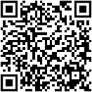
LECOM School of Health Services Administration
Teaching the Business of Healthcare



Dean, Timothy S. Novak, D.B.A., M.S.A., FACHT Administrative Assistant, Diana Hohman
941-405-1516 tnovak@lecom.edu 941-405-1533 dhohman@lecom.edu

Graduate Degree Programs
Doctor of Healthcare Administration (DHA)
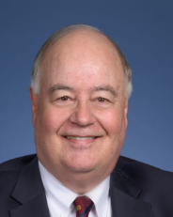 941-405-1556dhenderson@lecom.edu
Program Director: Donald Henderson, D.H.A., M.A., FACHE DHA Program Start Date: July (36 months)
DHA@lecom.edu 72 credit hours

Masters in Health Services Administration (MHSA)
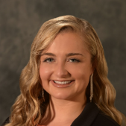

941-405-1687 nnovak@lecom.edu
MHSA Program Start Date: June (24 months) 50 credit hours
Program Director: Natalie Novak, D.H.A., M.S.B.E. CAHME Accredited
MHSA@lecom.edu

Master of Science in Biomedical Ethics (MSBE)
Masters in Public Health (MPH)
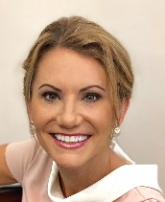
941-405-1641 bbrown@lecom.edu
MSBE Program Start Date: January
MSBE 36 credit hours (12 months)
MPH Program Start Date: June
MPH 45 credit hours (24 months)
Program Director: Bonnie W. Brown, Ph.D., M.Ed.
MSBE@lecom.edu MPH@lecom.edu

Master of Science in Medical Cannabinoid Therapeutics (MS MCT)
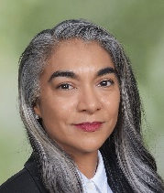
941-405-1558 sfayaz@lecom.edu MS MCT Program Start Date: January (18 months)
MS MCT 45 credit hours

Program Director: Sabrina Fayaz, MS MCSTS
MCT@lecom.edu

