LECOM School of Health Services Administration

***Teaching the Business of Healthcare***



**Dean**, Timothy S. Novak, D.B.A., M.S.A., FACHT **Administrative Assistant**, Diana Hohman

941-405-1516 [tnovak@lecom.edu](mailto:tnovak@lecom.edu) 941-405-1533 [dhohman@lecom.edu](mailto:dhohman@lecom.edu)

**Graduate Degree Programs**

**Doctor of Healthcare Administration (**[**DHA**](https://lecom.edu/school-of-health-services-administration/doctor-of-healthcare-administration/)**)**

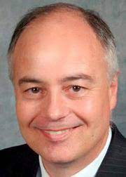 941-405-1556 [dhenderson@lecom.edu](mailto:dhenderson@lecom.edu)

Program Director: **Donald Henderson, DHA** Program Start Date: July (36 months)

[DHA@lecom.edu](mailto:DHA@lecom.edu) 72 credit hours

**Masters in Health Services Administration (**[**MHSA**](https://lecom.edu/school-of-health-services-administration/mhsa-program/)**)**

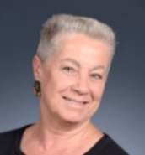

941-405-1535 [truno@lecom.edu](mailto:truno@lecom.edu)

Program Start Date: June (24 month) 50 credit hours

Program Director: **Terri Runo, M.H.S.A.**

[MHSA@lecom.edu](mailto:MHSA@lecom.edu)

**Master of Science in Biomedical Ethics (**[**MSBE**](https://lecom.edu/school-of-health-services-administration/msbe-program/)**)**

**Masters in Public Health (**[**MPH**](https://lecom.edu/school-of-health-services-administration/mph-program/)**)**

941-405-1641 [bbrown@lecom.edu](mailto:bbrown@lecom.edu)

Program Start Date: June (24 months)

MSBE 36 credit hours

MPH 45 credit hours

Program Director: **Bonnie W. Brown, Ph.D., M.Ed.**

[MSBE@lecom.edu](mailto:MSBE@lecom.edu) [MPH@lecom.edu](mailto:MPH@lecom.edu)

**Master of Science in Medical Cannabinoid Therapeutics (MS** [**MCT**](https://lecom.edu/school-of-health-services-administration/msct-program/)**)**

941-405-1558 [sfayaz@lecom.edu](mailto:sfayaz@lecom.edu) Program Start Date: June (24 months)

MS MCT 45 credit hours

Program Director: **Sabrina Fayaz**

[MCT@lecom.edu](mailto:MCT@lecom.edu)