**Lake Erie College of Osteopathic Medicine**



**Clinical Clerkship Manual**

1858 West Grandview Boulevard • Erie, PA 16509 • (814) 866-6641

5000 Lakewood Ranch Boulevard • Bradenton, FL 34211 • (941) 756-0690

20 Seton Hill Drive • Greensburg, PA 15601 • (724) 552- 2880

250 West Clinton Street • Elmira, NY 14901 • (607) 442- 3509

**The LECOM Clinical Clerkship Manual is a guide to assist each osteopathic medical student for success in clinical training. Every effort is made to provide each student the opportunity for the best possible clinical learning environment available. There may be changes in clinical education that occur after this manual is distributed that may supersede these guidelines.**

**Each student is responsible to keep updated when notified of these changes by Clinical Education and/or LECOM administration.**

**NOTICE**

## Table of Contents

|  |  |  |
| --- | --- | --- |
| **1.** | **INTRODUCTION** | 5 |
|  | 1.1. Philosophy, Goals, and Objectives of Clinical Training | 5 |
|  | 1.2. Department of Clinical Education | 7 |
|  | 1.3. Regional Deans | 8 |
| **2. CLINICAL ROTATIONS** | | **9** |
| 2.1. Definitions | | 9 |
| 2.1.1. Rotation | | 9 |
| 2.1.2. Core Rotations | | 9 |
| 2.1.3. Core Affiliated Hospital | | 9 |
| 2.1.4. Selective Rotation | | 9 |
| 2.1.5. Elective Rotation | | 10 |
| 2.1.6. Vacation Rotation | | 11 |
| 2.1.7. Clinical Education Enrichment (CEE) Rotation | | 11 |
| 2.1.8. Clinical Competency Development (CCD) Rotation | | 11 |
| 2.1.9. Senior Capstone (SC) | | 12 |
| 2.2. Requirements for Clinical Rotations | | 12 |
| 2.2.1. COMLEX Level 1 | | 12 |
| 2.2.2. Immunizations | | 13 |
| 2.2.3. Background checks | | 13 |
| 2.2.4. Insurance Requirements | | 14 |
| **3. SCHEDULING ROTATIONS** | | 15 |
| 3.1. Selection Process | | 15 |
| 3.1.1. Purpose of the Clinical Educational Site Assignment Process | | 15 |
| 3.1.2. Resources on Clinical Education Sites | | 15 |
| 3.1.3. Clinical Education Site Assignment Process | | 15 |
| 3.2. Core Rotation Schedule Changes | | 16 |
| 3.3. Non-Core Rotation Changes | | 16 |
| 3.4. Two Week Rotations | | 17 |
| 3.5. Special Applications for Rotations | | 17 |
| 3.6. Registration of Rotations | | 17 |
| 3.7. Cancellation of a Rotation | | 18 |
| **4. PROFESSIONALISM** | | **19** |
| 4.1. Professional Demeanor | | 19 |
| 4.2. LECOM Honor Code | | 19 |
| 4.3. Dress Code | | 19 |

* 1. Cultural Competency 19
  2. Ethical Standards 20
  3. Communication 20

1. ROTATION GUIDELINES 21
   1. Program General Information 21
      1. Teaching Techniques and Evaluation Methodology 21
      2. Patient Care 22
      3. Administrative Functions 22
   2. Orientation Guidelines/Hospital Experience 22
      1. Reporting for Service 23
      2. Hospital Rules and Regulations / Financial Responsibility 23
      3. LECOM Policy for Guest Housing 23
   3. General Clerkship Rules, Regulations, and Procedures 24
      1. Histories and Physicals 25
   4. Attendance Requirements 25
      1. Absences 25
      2. Illness 25
   5. Time Off Request 26
      1. Educational Seminars/Conferences 27
      2. Residency Interviews 27
      3. Personal Emergency 27
      4. Employment 27
      5. Travel Days 27
      6. Travel Delays 28
   6. Leave of Absence (LOA) 28
   7. Daily/Weekly Rotation Schedules 29
   8. Holidays 29
2. CURRICULUM 30
   1. Non-Cognitive Standards 30
   2. Basic Osteopathic Principles and Practice 31
   3. Clinical Web-Based Curriculum 32
   4. Clinical Curriculum for LDP, PBL and DSP 32
   5. Clinical Curriculum for APAP 33
   6. Clinical Curriculum for PCSP 34
   7. Clinical Competency Development (CCD) 35
   8. Family Medicine 35
   9. Selective Rotations 36
   10. Rural/Underserved Rotations 36
   11. Ambulatory Medicine 36
   12. Electives 37
   13. Research Elective 37
   14. Military Rotations 38
3. EVALUATION AND ASSESSMENT 39
   1. Introduction 39
   2. Student Evaluation and Grading 39
      1. Student Evaluation Form 39
      2. Electronic Evaluation Process 39
      3. Site Evaluations 41
   3. Rotation Grade Calculation 41
      1. Student Grades 41
      2. End-of-Rotation Subject Examinations 41

7.3.3 Remediation 43

* + 1. Clinical Web-Based Curriculum 44
    2. Questionable Evaluations 44
    3. Failures of Rotations and NBME Subject Exams 44
    4. Remediation/Professional Development 46
    5. Incomplete Grades 47
    6. Non-attendance Evaluations 47
    7. Non-registered Rotations 47
    8. Clinical Performance Tracking 47
    9. National Examinations 49

7.4 Student Assessment Review… 52

1. ADDITIONAL POLICIES AND PROCEDURES 53
   1. Fees 53
   2. Clinical Education Coordinator 53
   3. Clinical Academic Years OMS3 and OMS4 53
   4. Worker’s Compensation Insurance 53
   5. Needle Stick/Blood Borne Pathogen 53
   6. Address Change 54
   7. Health Insurance Portability and Accountability Act of 1996 (HIPAA) 54
   8. General Liability Insurance 54

8.9 Student email signature 55

8.9 Behavioral Health Resources 55

1. PREPARING FOR RESIDENCY 56
   1. Overview of the Electronic Residency Application Service (ERAS) and Career Resources 56
   2. Letters of Recommendation 57
   3. Setting up ERAS (Electronic Residency Application Service) 57
   4. Dean’s Letter Requests 57
   5. Registering for the Main Residency Match 57
   6. Career Counseling 58
2. APPENDICES 59
   1. Appendix A: Immunizations 59
   2. Appendix B: Background Checks 59
   3. Appendix C: Non-involvement of Providers of Student Health Services in Student Assessment and Promotion (COCA) 60
   4. Appendix D: Access to Core Affiliated Hospital Information on the Student Portal 61
   5. Appendix E: EPAs (Entrustable Professional Activities) 63
   6. Appendix F: Rotation Descriptions/Elective/Selective 64
   7. Appendix G: General Patient Encounter Objectives 65
   8. Appendix H: Student Request Form for Excused Absence 67
   9. Appendix I: Standards of Excellence 68
   10. Appendix J: Quarantine and Didactics 69
   11. Appendix K: Elective & Selective Matrix 71
   12. Appendix L: Clinical Rotation Performance Evaluation Form 76
3. **INTRODUCTION**
   1. **Philosophy, Goals, and Objectives of Clinical Training**

The philosophic framework of clinical education and training at LECOM is that of preparing students to become osteopathic physicians possessing the highest competencies in the profession. The program will educate students to become competent physicians who clearly recognize their roles as providers of comprehensive healthcare to the individual, family as a unit, and community. Osteopathic physicians must be able to function in the role of leader of a healthcare team to bring about needed change from the level of the individual to the level of the community. The ultimate intent of the program is to prepare physicians who will positively impact the quality of healthcare delivery systems and improve access for individuals and their families.

In today's healthcare world, physicians are integral to the efficient functioning of the healthcare system. Students' attitudes and learning will be directed toward understanding the role of the primary medical manager while recognizing the need for consultation with other medical specialists when appropriate.

We believe the physician must assume a leadership role not only in the medical community but also in the broader community in which they serve. Community leadership is an integral part of improving the healthcare of a community as a whole; thus, osteopathic physicians must be motivated toward the prevention of illness and upgrading of the delivery of healthcare services at extended levels.

#### Goals

In pursuit of its goal of excellence, the LECOM clinical curriculum is a challenging blend of the traditional and innovative, designed to:

* + - Foster the analytic and problem-solving skills requisite for osteopathic physicians involved in disease prevention, diagnosis, and treatment of individual patients, in families, communities, and populations at large.
    - Ensure the acquisition of basic clinical knowledge and essential clinical skills, including the integration of Osteopathic Principles and Practices (OPP).
    - Develop an understanding of contemporary healthcare delivery challenges.
    - Cultivate effective physician-patient relationships based upon integrity, respect, and compassion.
    - Develop high ethical standards.
    - Promote a lifelong commitment to learning.

#### Objectives

As a result of the two years of clinical training, students will see the physician as being able to:

* + - Demonstrate profound clinical excellence, using current biomedical knowledge in identifying and managing the medical problems presented by their patients.
    - Provide continuing and comprehensive care to individuals and families.
    - Demonstrate the ability to integrate the behavioral/emotional/social/environmental factors of families in promoting health and managing disease.
    - Recognize the importance of maintaining and developing the knowledge, skills, and attitudes required for the best in modern medical practice in a rapidly-changing world and pursue a regular and systematic program of lifelong learning.
    - Integrate the application of the Osteopathic structural exam and the application of Osteopathic Manipulative Treatment (OMT) in patient care.
    - Recognize the need and demonstrate the ability to use consultation with other medical specialists while maintaining continuity of care.
    - Share tasks and responsibilities with other health professionals.
    - Be aware of, understand, and critically evaluate the findings of a body of research, and apply the results to clinical practice.
    - Manage their practice in a business-like, cost-efficient manner that will provide professional satisfaction and time for a rewarding personal life.
    - Serve as an advocate for the patient within the healthcare system.
    - Assess the quality of care provided and actively pursue measures to correct any identified deficiencies.
    - Recognize community resources as an integral part of the healthcare system; participate in improving the health of the community.
    - Inform and counsel patients concerning their health problems, recognizing and valuing differences in patient and physician backgrounds, beliefs, and expectations.
    - Develop mutually satisfying physician-patient relationships to promote comprehensive problem-identification and problem-solving.
    - Use current osteopathic medical knowledge to identify, evaluate, and minimize risks for patients and family.
    - Balance potential benefits, costs, and resources in determining appropriate interventions.

## Department of Clinical Education

**Michael P. Rowane, DO, MS**, Associate Dean of Clinical Education Phone: (814) 866-8118; email: [mrowane@lecom.edu](mailto:mrowane@lecom.edu)

#### Travis M. Smith, DO, Associate Dean of Clinical Curriculum Assessment and Integration

#### Phone: (904) 742-6128; email: [travis.smith@lecom.edu](mailto:travis.smith@lecom.edu)

#### James P. Toldi, DO,

#### Assistant Dean of Clinical Education and Assessment, LECOM Bradenton Phone: (941) 782-5969; email: [jtoldi@lecom.edu](mailto:jtoldi@lecom.edu)

**Richard R. Terry, DO, MBA**, Associate Dean of Academic Affairs, LECOM Elmira

Phone: (607) 442-3509; email: [rterry@lecom.edu](mailto:rterry@lecom.edu)

**Kevin A. Thomas, DO, MS**, Assistant Dean of Institutional Enrollment Management & Clinical Education; Director, Accelerated Physician Assistant Pathway (APAP)

Phone: (814) 866-8117; email: [kthomas@lecom.edu](mailto:kthomas@lecom.edu)

**Jennifer Murphy, MA**, Director of Clinical Education Outreach

Phone: (814) 866-5133; email: [jennifer.murphy@lecom.edu](mailto:jennifer.murphy@lecom.edu)

**Regional Deans**: LECOM Regional Deans are assigned to specific geographic locations.

**LECOM Erie/Seton Hill Clinical Education Department Staff Contact Information**: **Katy Zech Uhlman**-Clinical Education Coordinator (Class of 2023/2025)

Phone: (814) 860-5139 email: [kzech@lecom.edu](mailto:kzech@lecom.edu)

**Karli Pulice**-Clinical Education Coordinator (Class of 2022/2024) Phone: (814) 860-5138 email: [kpulice@lecom.edu](mailto:kpulice@lecom.edu)

**Carolyn Heidt**-Clinical Education Coordinator

Phone: (814) 860-8404 email: [cheidt@lecom.edu](mailto:cheidt@lecom.edu)

**LECOM Bradenton Clinical Education Department Staff Contact Information**: **Erin Stearns**-Clinical Education Program Supervisor

Phone: (941) 782-5582 email: [estearns@lecom.edu](mailto:estearns@lecom.edu)

**Alexandria Hennessey –** Administrative Assistant

Phone: (941)-782-5977 email: [ahennessey@lecom.edu](mailto:ahennessey@lecom.edu)

**Christine Jagannath**-Clinical Education Assistant

Phone: (941) 782-5597 email: [cjagannath@lecom.edu](mailto:cjagannath@lecom.edu)

**Becca Middleton** – North Florida Regional Coordinator

Phone: (386) 530-1088 email: [rmiddleton@lecom.edu](mailto:rmiddleton@lecom.edu)

**LECOM at Elmira Clinical Education Department Staff Contact Information**: **Jennifer Spencer**- New York Regional Clinical Education Coordinator

Phone: 607-442-3541 (Elmira Campus) or 607-442-1713 (Arnot GME) email: [j spencer@lecom.edu](mailto:jspencer@lecom.edu)

**Patricia “Patty” Stein**-Clinical Education Coordinator

Phone: (607) 442-3576 email: [pstein@lecom.edu](mailto:pstein@lecom.edu)

## Regional Deans/Clinical Directors

|  |  |
| --- | --- |
| **Northwestern Pennsylvania**  Richard Ortoski, DO (814) 866-8446  [rortoski@lecom.edu](mailto:rortoski@lecom.edu) | **AHN/ Northwestern Pennsylvania**  Caitlyn Clark, DO  (814) 452-5120  Caitlyn.clark@ahn.org |
| **Southwestern Pennsylvania** Steven Wolfe, DO, MPH (412) 457-1092  [Steve.Wolfe@ahn.org](mailto:Steve.Wolfe@ahn.org) | **Southcentral Pennsylvania/Maryland**  Michael Hoh, DO  (814) 226-1326  [michael.hoh@lecom.edu](mailto:michael.hoh@lecom.edu) |
| **New York State/Southern Tier**  Richard Terry, DO, MBA (607) 737-8146  [rterry@lecom.edu](mailto:rterry@lecom.edu) | **Eastern Pennsylvania & Midwest/Ohio**  Michael P. Rowane, DO, MS (814) 866-8118  [mrowane@lecom.edu](mailto:mrowane@lecom.edu) |
| **New York/Elmira Region**  John Weston, DO  (607) 442-3517  [jweston@lecom.edu](mailto:jweston@lecom.edu) | **New York City Region**  Michael DiGiorno, DO/Miriam Kulkarni, MD  (914) 798-8971  [mdigiorno@riversidehealth.org](mailto:mdigiorno@riversidehealth.org)  [MKulkarni@riversidehealth.org](mailto:MKulkarni@riversidehealth.org) |
| **Mohawk Valley Health System**  Leonard Sullivan, MD; ℅ Arnela Lozic B.S. (315) 624-4702  [alozic@mvhealthsystem.org](mailto:alozic@mvhealthsystem.org) | **Rochester Regional Health**  Matt Devine, DO  (585) 794-8476  [Mathew.Devine@rochesterregional.org](mailto:Mathew.Devine@rochesterregional.org) |
| **Bradenton/St. Pete Region/Central Florida**  James Toldi, DO (941) 782-5969  [jtoldi@lecom.edu](mailto:%20%20%20%20%20%20%20jtoldi@lecom.edu) | **Northeast Florida (Jacksonville Region)**  Randy Scott, DO (305) 975-8583  [rscott226@gmail.com](mailto:rscott226@gmail.com) |
| **Southeast Florida (Miami Region)**  Susan Manella, DO (954) 381-8989 (Office)  [smanella@bellsouth.net](mailto:smanella@bellsouth.net) | **Flagler/Advent North Consortium Florida Region**  Travis M. Smith, D.O. (904) 742-6128  [travis.smith@lecom.edu](mailto:travis.smith@lecom.edu) |
|  | **Baptist East (Jacksonville)**  Danny Pulido, MD  [juanpulidomd@gmail.com](mailto:juanpulidomd@gmail.com) |
| **Primary Care Scholars Pathway** Richard Ortoski, DO, Director (814) 866-8446  [rortoski@lecom.edu](mailto:rortoski@lecom.edu) | **Accelerated Physician Assistant Pathway**  Kevin Thomas, DO, MS, Director (724) 552-2878  [kthomas@lecom.edu](mailto:kthomas@lecom.edu) |

1. **CLINICAL ROTATIONS**
   1. **DEFINITIONS**

**2.1.1. Rotation**

The term rotation, or clerkship, is a period of clinical exposure and education. The student works under the supervision of a teaching physician, who is referred to as the preceptor. Clerkship experience may be in a hospital, outpatient office-based, or hybrid setting.

The clerkship period is four weeks in length, which is referred to as a time slot (TS). Each rotation is ten credit hours which is based on forty working hours per week, as well as the completion of online curriculum and study for end-of-rotation subject examinations. Weekends and on-call hours are at the discretion of the preceptor and/or Regional Dean/Director of Medical Education. The daily schedule is set by the preceptor/Designated Institutional Officer (DIO)/Regional Dean at each site.

* + 1. **Core Rotations**

The subjects of Family Medicine, Internal Medicine, Geriatrics/OPP, Obstetrics and Gynecology, Pediatrics, Psychiatry, Surgery, Ambulatory Medicine, and Emergency Medicine are considered core rotations. The purpose of core rotations is for students to develop a solid foundation in osteopathic medicine. Core rotations are included in both the third and fourth-year curriculum. These core rotations must be completed at a core affiliate site and are found on the student’s schedule via the LECOM portal. The Department of Clinical Education sets the rotation sequence; Core rotations are scheduled by the Department of Clinical Education. The LECOM online web-based curriculum is a mandatory didactic component to every core clerkship rotation.

### Core Affiliated Hospital

A core affiliated hospital is defined as a hospital that has formally agreed to accept LECOM students on a regular basis for certain core, selective, and elective rotations.

### Selective Rotation

The OMS4 curriculum includes three Selective rotations: Primary Care, Medical, and Surgical. Selective rotations are to be completed at a core affiliate site unless another site is approved by the Regional Dean and Clinical Education. A selective rotation at a non-affiliated site will need to be arranged following the same procedure as an elective rotation. Selective rotations can occur at a core site, as well as any hospital, health care center, ambulatory practice, or clinical training site. Appendix K of this manual outlines which sub-specialties qualify as a Primary Care, Medical, or Surgical Selective.

### Elective Rotation

The purpose of elective rotations is to provide students with the opportunity to gain clinical experience in a preferred medical specialty. Students are provided one elective rotation during the third year and up to three electives during the fourth year. These rotations can be served at any location, in any clinical subject matter under the direction of a physician who commits to supervising and providing an end-of-rotation assessment on the student. Elective rotations are subject to the approval of the Associate Dean/Assistant Dean of Clinical Education.

Research electives are permissible but must be pre-approved by the Associate Dean/Assistant Dean of Clinical Education upon written request by the student with a designated research mentor. A research project must result in a poster that is submitted to a LECOM Interprofessional Research Day.

Students have the opportunity and are encouraged to arrange their own electives to allow exposure to specialties they are considering for residencies which would strengthen their residency applications. Students must arrange their own electives, which are scheduled in four-week blocks at one site only. Electives at the same site may be split into two (2) two-week periods. Requests for an elective that does not follow a typical four-week rotation schedule, will be considered on a case-by-case basis and need to be approved by the Regional Dean and Clinical Education. For those who are unable to coordinate an elective, the Department of Clinical Education will assist students in obtaining elective rotations.

Electives should be in person clinical rotations. Only in cases with exceptional circumstances should a virtual rotation be requested. This request must be approved by both the Regional Dean and Clinical Education.

The Regional Dean and/or Associate Dean/Assistant Dean of Clinical Education can require elective rotations to strengthen clinical training deficits and/or require a student to utilize elective time for a structured on-site rotation focused on concentrated learning. This will be necessary if the student has identified areas of concern.

Electives must be submitted for approval no later than 30 days prior to the start of the rotation. Students who do not submit an elective within that timeframe will be subject to be assigned an elective rotation that is available by the Department of Clinical Education, which may include a location at a site distant from the student’s current location. In addition, failure to submit a rotation request within the 30 days or communicate with the Clinical Education Department will be subject to the following:

* + - * 1st offense: A letter grade reduction, assigned rotation to be placed by the clinical education department, and possible referral to SPG for lack of professionalism.
      * 2nd offense: A two-letter grade reduction, the student's vacation will be swapped out for the upcoming rotation. If the student does not have a vacation left, the student will be off-cycle and the rotation will be made up following TS13 in June. The rotation will be selected by the clinical education department. The student will be referred to SPG for lack of professionalism.
      * 3rd offense: A maximum of 70% for the rotation. The student will be placed off-cycle and the rotation will be made up following TS 13 in June if still available. The rotation will be selected by the clinical education department. The student will be referred to SPG for lack of professionalism.

### Vacation Rotation

Vacation rotations are designated for time off. However, they are also an opportunity for the student to gain experience at a training site, make contacts, and network, while developing clinical skills and a broader medical knowledge base. Vacation rotations are not for credit and may not be converted for credit. Students can be seen on audition rotations, as well as receive letters of reference from attending physicians during this rotation to be used for residency applications. Vacation rotation blocks are the first sequence to be utilized for required remediation if needed.

### Clinical Education Enrichment (CEE) Rotation

Clinical Education Enrichment (CEE) is the first rotation of third-year and is a structured clinical rotation designed to provide the student with additional protected time for concentrated learning, which can also be used to prepare for the COMLEX Level 1 and USMLE Step 1 board examinations. This virtual or in person structured rotation includes modules in Clinical Reasoning as well as required learning modules. The final grade for the rotation block will be based on a combination of the student’s COMLEX Level 1 grade (P/F), and the required online curriculum. Students are required to be in the vicinity of their core site during this time slot as many sites will have meetings and orientation during this time.

Students with designated risk factors will be required to attend an in-person CEE rotation at a designated LECOM campus or LECOM Regional campus site.

### Clinical Competency Development (CCD) Rotation

Clinical Competency Development (CCD) is the first rotation of fourth year and is a structured clinical rotation that includes modules in Clinical Reasoning as well as required learning modules. Although this rotation is not a dedicated board preparation month, there is ample time in the day after completing the required clinical reasoning coursework to study for boards. Students desiring to improve upon their medical knowledge base may opt for either formal or informal review courses. Select students may be required to attend a formal review. This selection will be based on a “Comprehensive Exam” that all students will take at the end of TS-13 of their third year. This exam is mandatory for all students. Please see the below bullet points for this process.

Students with designated risk factors (Failure of COMLEX Level 1; failure of more than 3 subject exams; COMSAE Level 2 less than 400; or failing 3 subject exams and not achieving a 450 on the COMSAE Level 2), will be required to attend an in-person CCD rotation at a designated LECOM campus or LECOM Regional campus site.

The grade for this rotation will be a combination of the student’s COMLEX Level 2-CE examination, which is converted to a grading scale out of 100. (Please refer to section 6.7 for this conversion table) Similar to the CCE, the final grade for the rotation block will be based on a combination of the student’s COMLEX Level 2 examination score (converted), COMSAE Level 2 score (converted), and the online curriculum coursework component. The Clinical Reasoning component includes readings, podcasts, and live Clinical Reasoning sessions with the Clinical Problem Solvers.

* + - * **COMSAE** (For the COMLEX Level 2 CE) will be administered during the last block for the OMS3 group (TS13).
        + This is a formative exam for all students, which requires achieving a score of 450 or greater to be permitted to take the COMLEX Level 2 CE
        + Students who have failed 3 or more subject/shelf exams must pass the comprehensive exam (>400) to transition to their OMS4 year.

#### COMLEX Level 2 CE:

* + - * + SHOULD be taken by the end of the CCD block (usually the third week)
        + MUST be taken by end of TS2.
        + Students wishing to take the COMLEX Level 2 CE prior to their OMS4 year can if:

Complete all rotations by TS12 of OMS3 year. (Have a vacation for TS13)

Score at least a 500 on the COMSAE.

### Senior Capstone (SC)

The Senior Capstone is a fourth-year clinical rotation designed to provide the student with additional coursework in the following areas:

* Interprofessional education
* Osteopathic principles, and practices
* Physician wellness
* Career Counseling (1:1 meeting with Regional/Clinical Dean)
* Pain Management Assessment and Treatment
* Self-directed learning

The senior capstone requires a two-week period for a clinical rotation. The intention is to offer additional exposure to strengthen the student's application for residency.

A 1:1 career counseling meeting with the students assigned Regional/Clinical Dean will complement the self-directed learning activities students identify to enhance their career goals. All forms must be completed and submitted to the respective Regional/Clinical Dean with adequate time for review prior to the 1:1 meeting. (NOTE: This component must be completed PRIOR to September 1st of the academic year no matter when the Senior Capstone is scheduled.)

The student will receive a Pass/Fail for their Senior Capstone grade, which is determined by completing all rotation assignments, including submission of self-reflective papers to their portfolio.

## Requirements for Clinical Rotations

### COMLEX Level 1

Students must obtain a passing grade on the COMLEX 1 examination in order to be permitted to continue rotations. All students will take a COMSAE Level 1 examination at the end of the OMS2 year. Unless directed otherwise by the Clinical Education Dept., all students must take COMLEX Level 1 by end of TS2. Students who do not take COMLEX Level 1 by their second clinical rotation or time slot three (3) of the third year, will be removed from rotations and placed Off Schedule until they take the examination. The student must then make up any rotations missed in order to move on to their fourth year. This may result in a delay in graduation, resulting in ineligibility to participate in the current NRMP Match cycle.

### 2.2.2. Immunizations

In order for students to be permitted to enter the clinical environment, they must first receive certain immunizations. Please refer to Appendix A for details regarding necessary immunizations and due dates. These requirements can be found on E*Value and must all be completed by **April 1st** of the OMS2 year. E*Value notifies each student via email when an immunization will soon expire. Students with expired immunizations are not permitted to rotate at any hospital. If a student’s rotation site requires any additional immunizations, including a drug screen, it is the student’s responsibility to complete and submit them to the site.

LECOM does not mandate that students receive the COVID-19 vaccine and exemptions for medial and religious reasons can be submitted. The limitation is that LECOM has no authority on the health care facilities that students receive clinical training. Determining what immunizations are required and a decision on exemptions is at the sole discretion of each training site. Students unvaccinated for COVID-19 may not obtain clinical training due to clinical site requirements, regardless of requests for an exemption. Clinical training is required for advancement, applying for a residency program, graduating, and entering a residency.

### Background checks

Students are required to submit a new set of three background checks (Acts 34, 151, and 73) for **EACH CLINICAL YEAR**, which requires completion and submission of the LECOM Information Release for Background Checks Waiver. Additional information regarding background checks can be found in Appendix B of this manual. Failure to renew this on time will result in you being pulled off rotations until completed.

Students must also complete the required PA Child Abuse Training and submit a copy of that certificate during their first year of matriculation at LECOM. Online coursework must be completed, and background checks must be submitted by April 1st of OMS2. Failure to renew or have this completed will result in you being pulled off rotations until completed.

### Insurance Requirements

#### LECOM will assume NO FINANCIAL RESPONSIBILITY for injuries (e.g., accidental needle sticks, burns, laceration, etc.) or medical/surgical problems incurred either on or off clinical rotation.

Enrollment in the LECOM Student Health Plan is mandatory for all LECOM students on rotations. Enrollment in the student plan shall commence with June 1 of the rotating student’s first clinical year. **WAIVERS ARE NOT ACCEPTED**.

# SCHEDULING ROTATIONS

## Selection Process

### Purpose of the Clinical Educational Site Assignment Process

To assign each student to a year-long core site(s) for their clinical training as an OMS3 and OMS4 student. The process requires students to investigate all potential year-long clinical training sites so they can rank them in order of preference. This prepares the student for a similar process of investigating potential residency programs prior to entering the residency matching process.

### Resources on Clinical Education Sites

Information is provided on all the core affiliated hospitals that students can choose for their year-long core site during their OMS3 and OMS4 years of training. This information can be found on the [LECOM Portal](https://portal.lecom.edu/ICS/Clinical_Education/Clinical_Handbook_and_Rotation_Resources.jnz). Students are encouraged to become familiar with each year-long clinical training site profile. This document includes key features, student characteristics that are a good fit for that site, residency programs, site contacts, and additional information, including the website link so that the student has access to the site’s demographics, location, and clinical resources. Additional information regarding access to core affiliated hospital information on the LECOM Student Portal can be found in Appendix D of this manual.

### Clinical Education Site Assignment Process

#### BACKGROUND:

The E*Value Optimization Scheduling (**EVOS**) tool will be used to assign students to their year-long clinical site assignment. EVOS utilizes an algorithm in which every student’s preferences are taken into account. Each student’s preferences are reviewed by the optimizing program simultaneously to determine the best possible clinical training site assignment and schedule for every student.

#### PROCESS:

**June-October**: Clinical Education surveys all LECOM affiliated training sites to determine the number of year-long students and/or clinical rotation capacity for all specialties for the subsequent academic year. LECOM affiliated training sites are requested to identify their capacity for rotations and if all core rotations are available, as well as their allocated year-long students by November. Students need to research all potential core year-long training sites to identify the sites that are unable to offer all core rotations prior to submitting rank choices.

**August-November**: The Associate/Assistant Dean of Clinical Education will give presentations to each OMS2 class at each campus to discuss clinical training, the available core clinical training sites, and the E*Value Optimization Scheduling (EVOS) tool to assign students to their year-long core clinical training site.

**November-December**: The number of available year-long positions at each core training site will be made available to each OMS2 class. Specific dates will be identified for students to rank their selections in E*Value in order of preference over several days. LECOM Erie/Seton Hill, LECOM Bradenton, and LECOM at Elmira campuses will participate in the E*Value Optimization process together.

Each LECOM campus will identify priority regions of the country that are designated for that campus. LECOM Bradenton will be assigned all training slots in Florida.. LECOM at Elmira will complete all clinical training in New York and in the Southern Tier region. LECOM Erie and LECOM at Seton Hill have protected sites in Western Pennsylvania.

##### In summary, LECOM Bradenton, LECOM at Elmira, LECOM Erie, and LECOM at Seton Hill will complete the E*Value Optimization process together. Students at each campus will have regions of the country that are designated as a priority for that campus.

**December-January**: The Office of Clinical Education will be notified of the E*Value Optimization results prior to these results being released to the students in order to review assignments for accuracy. The EVOS tool will be utilized in a two-phase process: First, members of the OMS2 class will be informed of their year-long site assignments. Second, the sequence for each will be finalized.

***NOTE: Clinical Education may limit sites a student is assigned to for their year-long clinical site assignment based on academic or clinical/professional performance concerns.***

## Core Rotation Schedule Change

Once the student’s schedule is finalized, there will be no changes allowed –except for extenuating medical, financial, or personal hardships, which will be reviewed and are at the discretion and written approval of the Associate Dean/Assistant Dean of Clinical Education.

NOTE: A hardship is defined as a medical condition or injury of an acute but temporary nature, or the existence of a threat to the integrity of the student or their family, which impedes or prohibits the student from making satisfactory progress toward the completion of the COM requirements.

## Non-Core Rotation Changes

No changes are allowed, except for extenuating medical, financial, or personal hardships, which will be reviewed and are at the discretion and written approval of the Associate Dean/Assistant Dean of Clinical Education.

Students are not permitted to rearrange their normal working schedule to allow for time off during any rotation. Rotations are to be four weeks long in duration and a minimum of forty hours per week.

## Two-Week Rotations

Two-week rotations are not authorized for electives unless used during a vacation rotation. Electives at the same site may be split into two (2) two-week periods, but this is an exception, not the rule. All students will have a two-week clinical experience during the Senior Capstone rotation as an OMS4. The Senior Capstone two-week rotation must be submitted to the LECOM Portal. In the comments section, the dates the student is at the clinical site must be documented. Additional information regarding vacation rotations can be found in section 2.1.6.

## Special Applications for Rotations

Any forms required by the rotation site, in addition to LECOM’s issued data, must be completed in full by the student prior to submission to the Clinical Coordinator/ CE Office. Student immunization data and clearance records are available to a site’s coordinator on E*Value.

## Registration of Rotations

Core rotations – Core rotations are scheduled by the Department of Clinical Education only. Students are unable to change scheduled rotations at core sites. **STUDENTS ARE NEVER PERMITTED TO ALTER THEIR ROTATION SCHEDULE.**

Elective/Selective rotations – Requests ***SHOULD*** be submitted to the Department of Clinical Education at **60 days prior** to the beginning of the rotation time slot. Requests ***MUST*** be submitted to the Department of Clinical Education at **30 days prior** to the beginning of the rotation time slot. Requests are submitted via the LECOM portal under the Clinical Education tab. Students must receive written approval from the appropriate medical education coordinator, DME/Regional Dean, and/or physician's office before submitting a rotation request for approval. **If a rotation request is not submitted and/or there is no communication with the clinical education department at least 30 days prior, the student’s grade for that rotation can be subject to a letter grade reduction**. Students will not be penalized for rotations that fall through with proper documentation or they are not able to acquire a rotation on their own but communication is a MUST. Failure to submit the appropriate forms within the time frame allotted may also result in the student’s rotation being chosen by the Associate Dean/Assistant Dean of Clinical Education.

* + - Students are not permitted to be on a rotation without the approval of the Department of Clinical Education.
    - No grade will be given for any rotation completed by the student without the written authorization of the Clinical Education Office.

## Cancellation of a Rotation

Core Rotation – Only the Regional Dean and Department of Clinical Education may cancel core rotations.

Elective/Selective Rotation – If a student must cancel an elective/selective rotation, they must notify both the site and the Department of Clinical Education **no later than eight weeks (60 days) prior to the start of that rotation time slot**. Requests submitted by a student to cancel a rotation less than eight weeks prior to the start of the rotation will not be accepted. Students violating this policy will be subject to review by the Student Promotion and Graduation Committee.

**NOTE**: This policy is necessary because many hospitals around the country reserve elective slots for students and may turn away students from other schools only to find out, usually upon short notice, that the student who signed up for the rotation is not coming and a desirable rotation slot is wasted. This is unfair to the hospital and more importantly, it is unfair to fellow students.

#### The Lake Erie College of Osteopathic Medicine reserves the right to remove any student from clinical rotations at any time due to any academic, professional, or behavioral developments brought to their attention and will be at the disciplinary discretion of the Regional Dean, their Associate and Assistant Deans of Clinical Education, and the Student Promotion and Graduation Committee.

1. **PROFESSIONALISM**
   1. **Professional Demeanor**

Students on rotation are required to conduct themselves in a professional, respectful, and reserved manner. They are to not contact any patients outside of their professional duties as a medical student. This includes any direct communication, through social media, or any other means. Any breach of appropriate behavior as determined by the attending preceptor, the host DME/Regional Dean, or the appropriate clinical dean will result in the student being pulled from rotation, failing the rotation, and automatically being placed on Disciplinary probation which stays a permanent part of their academic record. This could have negative consequences on the student’s ability to obtain a permanent medical license.

## LECOM Honor Code

Students on rotation are subject to compliance with all aspects of the LECOM Honor Code as well as non-honor code guidelines and regulations as outlined in the College of Medicine Academic Catalog and Student Handbook. Any violations will be adjudicated in accordance with the disciplinary procedures outlined in the Student Handbook.

## Dress Code

Students are to wear clean, non-wrinkled white clinic jackets with their name tags and otherwise dress in compliance with the LECOM Dress Code at all times including during their End of Rotation Exams.. Additional information regarding the LECOM Dress Code can be found in the Academic Catalog and Student Handbook, Sec. 4.3.3.Scrubs are only to be worn on the units requiring their wear and are not considered dress code outside of these specific areas. If a facility provides scrubs, they are the property of the hospital and are to be returned to the appropriate department after use.

Approved identification will be worn as dictated by each hospital. Students are required to carry their LECOM ID badges at all times. If you have lost your LECOM ID badge, you must contact the Director of Security at LECOM to obtain a new ID badge.

## Cultural Competency

Many training sites have a diverse patient population. There is an expectation that all individuals will be treated with respect and every effort to utilize cultural competency in every clinical encounter. Diverse patient populations may consist of individuals who are not fluent or able to communicate in English, including individuals who may be deaf. Every health care provider should take any measure possible to communicate with the population of patients that they serve effectively. The student is to recognize that many hospitals and clinical settings have staff, nurses, residents, and attending physicians who can communicate with non-English speaking patients, as well as individuals who are deaf. It is the responsibility of the student to reach out and utilize the local resources to aid in communication with non-English speaking and deaf patients

## Ethical Standards

Ethical standards outlined by the Code of Ethics of the American Osteopathic Association apply. That code can be found in the LECOM Academic Catalog and Student Handbook (Appendix J). Students are also expected to follow the LECOM “Standards of Excellence. (See Appendix I)

#### The Lake Erie College of Osteopathic Medicine reserves the right to remove any student from clinical rotations at any time due to any academic, professional, or behavioral developments brought to the attention of their Regional Dean and will be at the disciplinary discretion of the Regional Dean, the Associate and Assistant Deans of Clinical Education, and the Student Promotion and Graduation Committee.

## Communication

* **ANY E-MAIL COMMUNICATION FROM CLINICAL EDUCATION THAT REQUIRES A RESPONSE FROM THE STUDENT SHOULD BE ANSWERED WITHIN 48 HOURS.  ANY PHONE CALL FROM CLINICAL EDUCATION THAT REQUIRES A RESPONSE FROM THE STUDENT SHOULD BE ANSWERED WITHIN 24 HOURS**.  Failure to adhere to such requirements will result in the following administrative actions:
* A first offense will result in a meeting with clinical education.  At this meeting, disciplinary action may be taken and an official verbal warning will be given.
* A second offense will result in a meeting with clinical education.  At this meeting disciplinary action will be taken in the form of Admonition.
* A third offense will result in a meeting with clinical education to be scheduled where disciplinary action will be taken and a referral to the Student Promotion and Graduation Committee.

Unless it is an **emergency**, any e-mail or telephone communication from a student to clinical education should allow for the professional courtesy of a 48-hour response time.  Repeated attempts to contact clinical education, or any other departments, about a non-emergent condition within 48 hours will result in administrative actions.

1. **ROTATION GUIDELINES**
   1. **Program General Information**

The Clinical Clerkship Program is dedicated to the education of osteopathic medical students and is designed to provide the student with an education in the general areas of Internal Medicine, Surgery, Pediatrics, Geriatrics/OPP, Obstetrics/Gynecology, Psychiatry, Family Medicine, Rural/Underserved, Ambulatory, and Emergency Medicine.

The Clinical Clerkship Program is under the direct supervision of the Lake Erie College of Osteopathic Medicine, its Department of Clinical Education, and both the Assistant and Associate Deans of Clinical Education. LECOM has made affiliations with a wide range of hospitals, clinics, and physicians offering diverse training opportunities for its students. The program has been organized to permit the greatest degree of educational exposure in a clinical environment and to develop expertise in the area of patient diagnosis and management.

The rotations provided at each core affiliated site, and the number of students assigned to each core affiliated site from LECOM, are determined by mutual agreement with the Hospital Administrator, Director of Medical Education (D.M.E.), Regional Dean, Clinical Faculty, and the LECOM Office of Clinical Education. Information regarding core affiliated sites is available on LECOM’s portal and website.

### Teaching Techniques and Evaluation Methodology

Students will participate in a structured, systematic training experience on each service. Students will be assigned to a patient care team which may consist of residents, interns, and attending physicians. This structure will provide all participants with clearly delineated responsibilities for meeting educational objectives. The specific educational objectives for each core rotation are defined on the LECOM portal regarding OMS3 and OMS4.

Students must submit the following criteria to receive credit for a rotation: **student evaluation from the preceptor, online curriculum completion, and site evaluation including a summary of clinical experiences encountered during the rotation.** These criteria are to be submitted within E*Value. For core rotations, students must also complete the respective end-of-rotation quiz and subject exam. Additional information regarding evaluations can be found in Section 7 Evaluation and Assessment, as well as on the LECOM portal.

The student will be provided feedback by each of the responsible individuals in the teaching service through periodic oral evaluation and by observations of skill performance. The physician on the teaching service will complete subject-specific evaluations, which are available to clinical preceptors on E*Value.

In order for the student to progress from OMS3 into OMS4, each **student must complete an evaluation from the preceptor, completion of the online curriculums, and site evaluation including a summary of clinical experiences encountered for all their rotations**. They must also have completed all quizzes, subject exams, required remediations and passed the comprehensive exam if failures were encountered. The same criteria apply to a student progressing from OMS4 to graduation.

### Patient Care

Students will comply with all requirements related to patient care as established by the host institution. Patient encounters require a personal introduction, self-identification as a LECOM medical student, and the presentation of appropriate identification badges. For information regarding patient encounters, please refer to Appendix G: General Patient Encounter Objectives.

### Administrative Functions

* + - * Clinical clerkship coordination will be through the Office of the Associate Dean/Assistant Dean of Clinical Education of LECOM.
      * The hospital will specifically define the degree of student involvement in its own institution in consultation with LECOM.
      * Standards for medical students should be consistent regardless of their school of origin. Clerkship programs clearly define whether or not meals, laundry facilities, uniforms, and living quarters are provided. Students are responsible for retrieving this information from their site’s coordinator.
      * LECOM and each participating hospital will identify the personnel involved in teaching programs, including administrative personnel. This information can be found on the LECOM portal or by contacting the Department of Clinical Education.
      * Delivery of clerkship content, structure, and evaluation will be the responsibility of the appropriate departments of the hospital and approved by LECOM.
      * Any academic, professional, or performance difficulties in the program should be immediately communicated to the Regional Dean of the site and the Office of the Associate Dean/Assistant Dean of Clinical Education of LECOM.
      * On-site inspections by the Associate Dean/Assistant Dean of Clinical Education, a Regional Dean, or their appointee will be performed periodically.

## Orientation Guidelines/Hospital Experience

The student will be introduced to the clinical service by the Director of Medical Education and/or Chief of that service. The student will go through orientation, which varies by site. Reference to the rotation site includes the following: patient rooms, nurses’ stations, emergency department, ancillary services facilities (X-rays, laboratory, etc.), restrooms, lounges, cafeteria/coffee shop, or library.

The student will familiarize themselves with their rotation site by:

* + - Being provided detailed information regarding what is expected of them—including the time commitment to these duties.
    - Being informed of the criteria to be utilized in evaluating their performance.
    - Being informed as to who is responsible and how that person or those persons may be reached when needed.
    - Knowing initially whether the student may record on the patient's chart and, if so, what and where they may record.

**NOTE:** If the student does not receive the above-mentioned information at the beginning of the rotation, they are responsible for contacting the hospital DME/Region Dean or site coordinator for clarification. Violations of institutional procedures may jeopardize the student’s grade.

### Reporting for Service

At least four weeks prior to the start of the rotation, the student is responsible for contacting the facility to confirm the rotation (and housing if applicable). On the first day of each rotation service, the student should report to the Regional Dean/ Director of Medical Education at the time required by the DME or the clinical department supervisor. Students are expected to provide their own basic diagnostic equipment (i.e. otoscope, ophthalmoscope, stethoscope, etc.).

### Hospital Rules and Regulations / Financial Responsibility

Each hospital or health care system has rules and regulations. Medical students must familiarize themselves with and adhere to these protocols during training. Students must respect and follow all policies regarding the use of hospital facilities, housing, and equipment.

Students are financially responsible for any damage to or loss of hospital or training site-related property, including but not limited to library materials, pagers, and keys. Final grades may be withheld pending the return of all hospital or training site property.

### LECOM Policy for Guest Housing Provided by LECOM

* + - * No guests are permitted in visiting student quarters.
      * No alcohol is permitted to be in the visiting student quarters.
      * No smoking of any substance, vaping, or electronic cigarettes in the visiting student quarters.
      * No illicit drugs, weapons, or drug paraphernalia are to be in the visiting student quarters.
      * No pets or livestock are permitted in visiting student quarters.
      * No disorderly behavior is permitted in student quarters at any time.

#### Should there be a violation of this policy, the student will be subject to disciplinary action and reported to their Regional Dean, the Department of Clinical Education, and the Student Promotion and Graduation Committee.

**Year-long rotation sites**:

Year-long regional campuses do not offer free housing for students. Year-long students shall secure their own living quarters in the community to experience the community/cultural life of the patients they will be caring for as osteopathic medical students. A few sites offer living arrangements for year-long students, which requires students to contact those sites and individually make arrangements for housing. Information regarding site housing can be found on the LECOM portal.

## General Clerkship Rules, Regulations, and Procedures

The study and training of each clinical clerk during assignment to a training institution shall be governed by the following regulations:

* A licensed physician must supervise students. The student, while on a rotational service, will at all times be responsible to the personnel in charge of the unit involved.
* Students shall assume responsibility for and perform their assigned duties in accordance with the training institution regulations. Students will be expected to comply with the general rules established by the hospital or clinic at which they are being trained.
* Students shall not be permitted to accept financial compensation or any form of gratuity for rendering patient care.
* Students should be assigned to specific patients.
* Progress notes may be written by the students only under the direct supervision of the supervising physician. Progress notes must be countersigned within the time required by the rules and regulations of the training institution.
* Students shall not order any examinations, tests, medications, or procedures without consulting and obtaining the prior approval of the supervising physician. Students shall not write prescriptions for medicine, devices, or anything requiring the authority of a physician. The DME for each specific hospital will make clear to the student the policy of that hospital for order writing. Remember that a student is not a licensed physician, and all activities (orders are written or given, any patient care, progress notes, etc.) in a hospital are under the supervision of an attending physician who assumes responsibility for the student.
* Attendance by students is required at all conferences, discussions or study sessions, and any other programs of an educational nature designed specifically for students and should be documented with an attendance record. In addition, students should be encouraged to attend lectures for interns, provided these do not interfere with the student’s own program. A schedule of the hospital educational programs should be obtained each week or month from the Director of Medical Education/Regional Dean.
* Students shall be required to participate in the utilization of osteopathic manipulative treatment when ordered and supervised by the attending physician.
* Students shall learn and perform procedures under appropriate and proper supervision, in those areas where the training institution regulations permit such instruction.
* Students are expected to be engaged in educational activities every day of an assigned rotation. This should be an average of five (5) days a week and minimally forty hours a week of structured educational activities. This includes, but is not limited to, clinical duties, didactic offerings at the site, and those available virtually by LECOM.
* Students are required to complete all didactic curriculum that Dr. Travis Smith has developed and utilize the TrueLearn board question bank on each core rotation.
* Students on a core rotation, are tocomplete the readings, daily questions, human dx cases, and to log their daily activities in an excel sheet.
* All students are required to attend the LECOM Mandatory Grand Rounds. This will take place starting the week of July 1 every Thursday from Noon-1 pm for all 3rd and 4th-year students. For all 3rd year students, from 1:30-3:30 there is mandatory **Specialty Specific Didactics** and 3:30-5p is independent study. Students are required to keep a 50% rolling average of attendance. Failure to keep this attendance average will be sent to SPG. All students must be present with the

cameras on and be prepared and actively engaged.

* Students who cannot attend an in-person clinical elective rotation are to contact clinical education immediately.
* All problems or difficulties with attendance should be communicated first to the student’s Regional Dean.

### Histories and Physicals

* + - * LECOM believes in the importance of an educationally sound realistic policy pertaining to students doing histories and physicals (H&P's) in the core affiliated hospitals. Ideally, the H&P policy should be the same for all students. However, we realize the sovereignty of our core affiliated hospitals and acknowledge that our policy must be integrated with individual hospital policy.
      * The student, according to the rules and regulations of the training institution, may sign H&Ps. The H&Ps done by the students should be reviewed and countersigned by the supervising physician.
      * The office of the DME is responsible for the H&P policy for each hospital. If a clinical clerk has a problem or question concerning them, they should contact the DME's office of the core affiliated hospital.
      * H&P exams should be completed on those patients whom student clerks will be following, on the service to which they are assigned. Emphasis will be placed on the teaching and application of osteopathic principles and practice. Palpation and structural diagnosis in the narrative form shall be an integral part of the history and physical examination.

## Attendance Requirements

Attendance is mandatory. **Permission for an absence must be cleared in advance with all of the following offices:**

* + - LECOM Office of the Associate Dean/Assistant Dean of Clinical Education
    - Chief of training service or physician to whom the student is assigned
    - Regional Dean/Director of Medical Education of the hospital.
    - All students are required to attend the LECOM Mandatory Grand Rounds. This will take place starting the week of June 1 every Thursday from Noon-1 pm for all 3rd and 4th year students. (There may be special presentations during time slot 1 for CEE/CCD rotations.) For all 3rd year students, there is mandatory Specialty Specific Didactics from 130pm-330pm and then directed study from 330pm to 5pm. Students are required to keep a 50% rolling average of attendance. Failure to keep this attendance average will be sent to SPG.

#### NOTE: Students are expected to attend all didactics that are available to them. The 50% rolling average of attendance is to take into account when a student is on vacation, has an excused absence, such as a residency interview, the student is post-call, or has a conflicting clinical assignment.

### Absences

Excused absences: Absences for any reason must be submitted, in writing, to the LECOM Clinical Education office at their home campus for approval at least four weeks prior to the student’s absence. Examples of excused absences are subject exam testing, national exam testing, and interview days. Additional information regarding the Student Request Form For Excused Absence can be found in Appendix H of this manual.

#### Reminder: Students are permitted up to five excused absence days per rotation. Any more than five absence days may result in failure of the rotation.

Unexcused absences: Any absence that is unexcused by the Office of Clinical Education is cause for the individual to fail the rotation, be placed on Conduct Probation, and be referred to the Student Promotion and Graduation Committee for further review.

#### An unexcused absence will result in failing the rotation, the student being placed on Conduct Probation, and the makeup rotation being scheduled at the convenience of the Department of Clinical Education.

### Illness

**LECOM will assume NO FINANCIAL RESPONSIBILITY for injuries (e.g., accidental needle sticks, burns, laceration, etc.) or medical/surgical problems incurred either on or off clinical rotation**. Students are required to be covered by Health Insurance during rotation.

Failure to secure coverage will result in being pulled from rotations.

Any student becoming ill or injured while on rotations and needing time off from the rotation must notify the Attending Physician, the Office of Medical Education at the host site/Regional Dean, and the Office of Clinical Education at the student’s campus. **Absences of three or more days due to illness require a physician’s statement of fitness for duty to return to rotations**—this written note must be from a licensed physician that has personally taken care of the individual during this timeframe. Notes from distant physicians, relatives, and allied health professionals will not be accepted.

Any student becoming ill or injured while on rotations should seek treatment at the nearest appropriate facility (i.e., Emergency Department/Urgent Care Center). Students are not authorized to receive medical treatment from the physician evaluating them on rotation, i.e. their preceptor. Additional information regarding Non-involvement of Providers of Student Health Services in Student Assessment and Promotion (COCA) can be found in Appendix C.

## Time Off Request

If the student desires to participate in an activity that will take them away from an assigned clinical setting, the student must submit a **written request** which fully details the time away from assigned duty. This request must be submitted to the Department of the Associate Dean/Assistant Dean of Clinical Education no less than four weeks before any absences. The local Regional Dean/DME must be notified, as well as the assigned preceptor. Additional information regarding the Student Request Form For Excused Absence can be found in Appendix H of this manual.

### Educational Seminars/Conferences

Students wishing to attend educational seminars, conferences, etc. not occurring at the training site must have approval from the Associate/Assistant Dean of Clinical Education. Only students in “good standing” with a GPA of 3.0 or higher or an average score of 80 or higher at the end of their second academic year will be considered. In addition, students must have up-to-date submissions of all clinical rotation evaluations, site evaluations, and student logs. Any excused absence may, at the request of the Preceptor, DME, Regional Dean, or Associate Dean/Assistant Dean of Clinical Education, be required to be made up later.

Some rotation sites require the attendance of educational lectures and seminars. Students need to make themselves aware of their site’s policies regarding attendance at these events.

### Residency Interviews

Time off will be granted for internship/residency interviews during the 4th year up to a maximum of twenty (20) days. However, no more than five days (which would include interview days, travel days, and occurring holidays) may be missed during any four-week rotation block.

Students in the PCSP pathway may not exceed three interview days per time slot.

Again, permission must be cleared in advance with the aforementioned offices, precepting physician, DME/Regional Dean, and LECOM Clinical Education. **Any time missed beyond five days will result in the review by the appropriate Clinical Dean with actions for remediation, failing the rotation, and SPG referral.**

NOTE: Please to LECOM Portal “**Career Counseling**” tab for resident interviewing resources.

### Personal Emergency

If an emergency arises (family member death, illness, accident), the student or other responsible party should personally contact the physician (attending, resident, or intern) to whom assigned, the DME's/ Regional Dean’s office, and email the LECOM Clinical Education Office no later than the morning of the absence. If an illness is extensive, make-up time will be required.

### Employment

Employment during clinical rotations is not authorized. The clerkship program is full-time, and any other activities will not take precedence or conflict with the student's assigned/required duties—this includes extracurricular educational activities outside of LECOM.

### Travel Days

No travel time is given for rotation site changes. Rotations end on Friday at 5:00 PM (unless directed otherwise by the attending, DME/Regional Dean) with the next rotation beginning on the following Monday at 6:00 AM. That interval weekend is available for travel to the next rotation site. **No additional time will be given for travel.** Travel is at the expense of the student.

If a student is traveling over 200 miles to take a board examination, travel time is permissible. Students must submit a written request to the Department of Clinical Education at least two weeks prior to the exam date to be considered for a travel day.

* + - * NBME Subject Exams: Travel is not necessary at this time as these exams are taken within proximity to their core site.
      * COMLEX and USMLE: All students will be permitted the day before and the day of the exam away from rotations.
      * **Reminder: The maximum total number of excused days students are permitted to be absent from rotations is five (5).** Absence beyond this will result in the student not receiving credit for the rotation, and a new rotation will be scheduled at the convenience of the Department of Clinical Education.

### Travel Delays

In the event of a travel delay, the student should contact the host site and the Office of Clinical Education at the home campus immediately.

## Leave of Absence (LOA)

Leaves of absence must be requested in writing to the Clinical Education Department and then approved by the Dean of the college, detailing the need for the leave, as well as the expected outcome and return date. Additional information regarding Leaves of Absence are found in the COM Catalog, Appendix E (Request for Leave of Absence Form) and Appendix F (Leave of Absence Form for Financial Aid).

Once approved, the student will receive a letter detailing the terms of the leave and setting forth the requirements for return. A general guide of requirements for return to active matriculation is provided below:

##### Leave of Absence- Procedures to Return to Clinical Rotations

* **30 days or less a student must**:
  + Have met the requirements agreed upon at the granting of the LOA
  + Have tuition, fees, and insurance up to date
  + Meet with the appropriate Associate/Assistant Dean, either Preclinical or Clinical, before the return to the schedule.
* **More than 30 days and up to six (6) months a student must**:
* Meet all requirements of the 30 days or less
* Have a new drug screen less than 30 days old
* Have a new set of criminal screens less than 30 days old

#### More than six (6) months a student must:

* + Meet all requirements for one (1) to six (6) months
  + Meet the standard of the educational level being returned to
    - Between years two and three, take and pass COMSAE basic science exam.
    - Between years three and four, take and pass COMSAE clinical comprehensive exam.

#### All health-related LOAs a student must:

* Meet all requirements indicated by the time removed from rotations
* Must have a physician sign the release to return to rotations. This may be the same physician who made the diagnosis leading to the LOA or the present treating physician.
* Follow any State Board (PHP, or PRN) requirements in place or put in place during the student’s enrollment at LECOM.

## Daily/Weekly Rotation Schedules

Students are expected to be engaged in educational activities every day of an assigned rotation. The daily/weekly schedule is set by the attending/DME/Regional Dean at the rotation site. This schedule may include nights, call, weekends, and holiday duty. Students are not covered by regulations on hour restrictions. If unreasonable expectations appear to be present, the student should contact their Office of Clinical Education for advice.

**NOTE:** If the preceptor is absent for more than one day, the student is to notify the host DME/Regional Dean’s office and the Department of Clinical Education for guidance and reassignment.

## Holidays

LECOM excused holidays shall be

* + - Thanksgiving: Thanksgiving Day and the day after.
    - Christmas: Christmas Eve, Christmas Day, and the day after.

#### May be adjusted for call/coverage based upon rotation site need.

All other holidays will be observed at the discretion of the host Regional Dean/DME.

# CURRICULUM

## Non-Cognitive Standards

As future osteopathic physicians, medical students have a responsibility to guide their actions to serve the best interest of their fellow students, patients, and faculty. This responsibility is upheld by maintaining the highest degree of personal and professional integrity. To meet these objectives, the following standards are expected of all clinical medical students at LECOM.

Osteopathic medical students shall demonstrate dedication to acquiring the knowledge, skills, and attitudes necessary to provide competent medical care. They shall:

* + - Assume personal responsibility for their medical education. Continue to study, apply, and advance scientific knowledge and make relevant information available to patients, colleagues, and the public.
    - Seek appropriate consultation with faculty, staff, and colleagues in their interactions with patients.
    - Take an active role in the planning, implementation, and evaluation of the medical education process by a discussion with instructors and peers as well as through written evaluation.

Osteopathic medical students shall demonstrate the professional behavior expected of an osteopathic physician. They shall:

* + - Be truthful in carrying out educational and clinical responsibilities;
      * Never falsify information including patient histories, physical examinations, or laboratory data, or purposely misrepresent a situation, never tamper with, remove, or destroy patient records or educational materials, including slides or anatomical dissections.
    - Maintain confidentiality of information concerning patients and refrain from discussing cases except under appropriate circumstances.
    - Be punctual, reliable, and conscientious in fulfilling professional duties, including attendance at lectures, clinical rotations, and examinations.
    - Never participate in patient care when under the influence of any substance or other conditions, which could impair judgment or ability to function.
    - Maintain professional hygiene, demeanor, and appearance when in a patient care setting or representing LECOM.
      * Possess awareness regarding patient sensitivities to strong aromas.
    - Accept the responsibility to review plans or directives for patient care with the attending physician when, after careful consideration, the student believes that these plans or directives are not in the best interests of the patient.
      * Recognize when it is appropriate to request assistance from the medical team.
    - Clearly identify their role as medical students in the patient care setting.
    - Seek appropriate faculty supervision.
      * Observe, assess, and experience different scenarios. Participate with permission when it is appropriate to do so.
    - Respect civil and criminal laws, hospital rules, and LECOM rules governing the conduct of medical students.

Osteopathic medical students shall show compassion and respect for themselves, their families, their colleagues, faculty, staff, and, most importantly, the patients who participate in their education. They shall:

* + - Within the confines of professional confidentiality, establish rapport and deal honestly with patients, colleagues, faculty, staff, and the patient's family.
    - Treat with respect patients, their families, and their professional colleagues, including staff and other health care providers, regardless of their race, ethnicity, color, religion, creed, national origin, gender/sex, sexual orientation, gender identity or expression, age, marital status, disability, status as a veteran or disabled veteran, citizen (within the limits of the law), or any other legally protected characteristic.
    - Care for themselves by following good health maintenance practices related to physical and mental health and seek help in this regard when help is needed.

Additional information regarding the expected LECOM Standards of Excellence can be found in Appendix I of this manual.

## Basic Osteopathic Principles and Practice

Osteopathic education plays a key role in the entire curriculum. It should not be a segmented part of the program but rather integrated with all clinical services. Osteopathic care does not imply a set of manipulative techniques for specific problems, but rather the capability to look at the presenting complaints and to see persons in their entirety. The concept of holistic medicine (i.e., treating the whole person, both the physical and the psychological) is part and parcel of the osteopathic philosophy and as such is integrated into the entire clinical education program.

Therefore, the following objectives are applicable to all services, as appropriate:

Have knowledge of the osteopathic profession regarding all aspects of health care. Knowledge will be

* + - Concepts basic to osteopathic healthcare including the self-healing tendency/processes, the unity of the organism in its environment, and diagnostic and therapeutic manipulative processes including when and how to apply them.
    - The philosophy and principles of osteopathic medicine.
    - The history, growth, and development of the profession.
    - The effects of growth, development, and aging on the musculoskeletal system (normal and variations of normal).
    - Topical anatomy and neuroanatomy correlated with structural anatomy.
    - Anatomy and physiology of component parts and their basic inter-relationships within the musculoskeletal system.
    - Most frequently encountered structural anomalies and functional abnormalities in the musculoskeletal system at each age level.
    - Somatic changes occur as a result of distant disease processes and the relationship of these changes is delaying the resolution of the disease process.
    - Musculoskeletal evaluation procedures are suitable for each age group/situation.
    - Primary somatic changes resulting from anatomical syndromes and their relationship to other syndromes.
    - The applications of philosophy and principles in special situations within the life cycle.

Have an understanding of the osteopathic profession regarding all aspects of health care. To include the following:

* + - The relationship of the philosophy and principles of osteopathic medicine to concepts of health and disease.
    - The relationship of the philosophy and principles of osteopathic medicine to patient management.
    - The relevance of the philosophy and principles of osteopathic medicine to situations in each of the various specialties.
    - The impact of the philosophy and principles of osteopathic medicine on the practice of sub-specialty areas.

Demonstrate a purposeful intent:

* + - Application of basic osteopathic concepts to health care (diagnosis, treatment, variations, when and how to apply).
    - Use of osteopathic manipulative treatment techniques in diagnosing/treating problems in special situations (e.g., pregnancy, labor, pediatrics, surgery).
    - Using indications/contraindications for osteopathic manipulative treatment techniques in situations unique to the various specialties.
    - Using a variety of techniques in osteopathic manipulative treatment applied/adjusted to the unique needs of the individual patient (e.g., in terms of age, development, disorder).
    - Recognizing the relationship of disease/disorder of the musculoskeletal system to total well-being.
    - Writing of appropriate orders and progress notes relevant to the use of Osteopathic Manipulative Treatment.

## Clinical Web-Based Curriculum

At the start of the student’s third year, a tab labeled **Clinical Web-Based Curriculum** is found in CANVAS. Under each of the core rotations are assigned weekly readings, weekly True Learn questions, and an end-of-rotation quiz that must be completed by the specified completion date and time. Students must work in the curriculum weekly and progressively to be eligible for the points. The Clinical Web-Based curriculum also features weekly Morning Reports that are emailed out. These reports include facts of the day, board review questions, schemas, recommended podcasts, and Human Dx cases.

## Clinical Curriculum for LDP, PBL, and DSP

**Third Year Rotations**

* + - CEE-1001 – Clinical Educational Enrichment
    - DOR 1006 – Internal Medicine I
    - DOR 1008 – Internal Medicine II
    - DOR 1032 - Internal Medicine III
    - DOR 1007 – Surgery I
    - DOR 1009 – Surgery II
    - DOR 1010 – Obstetrics/Gynecology
    - DOR 1022 – Family Medicine
    - DOR 1018 – Pediatrics
    - DOR 1027 – Geriatrics/OPP
    - DOE 1001 – Elective
    - DOR 1011– Psychiatry/Behavioral Health
    - Vacation

**Fourth Year Rotations**

* + - DOR 1020 - Emergency Medicine
    - DOR 1036 – Senior Capstone
    - DOE 1010 ***–*** Medicine Selective
    - DOE 1011 ***–*** Primary Care Selective
    - DOE 1012 ***–*** Surgery Selective
    - DOR 1003 ***–*** Ambulatory Medicine I
    - DOR 1031 ***–*** Ambulatory Medicine II
    - DOR 1013 ***–*** Rural/Underserved
    - DOE 1003 ***–*** Elective I
    - DOE 1004 ***–*** Elective II
    - DOE 1006 ***–*** Elective III
    - DOE 1007 ***–*** Clinical Competency Development
    - Vacation

Students will not be allowed to sit for the COMLEX Level 2-CE examination or proceed into their fourth-year clinical rotations until all third-year exams and assignments, including all rotation evaluations have been successfully completed. Refer to the Department of Clinical Education for information on how these examinations apply to course grade evaluations.

## Clinical Curriculum for APAP

Please refer to the APAP Manual for complete details on the policies and procedures of this program.

Students enrolled in the APAP must complete rotations during years two and three. Clinical rotations for APAP students are approved by the Associate/Assistant Dean of Clinical Education.

Second Year Rotations

DOE 1023 – Family Practice/OMM DOR 1027 – Geriatric Medicine

Third Year Rotations DOR 1010 – OB/GYN

DOR 1006 – Internal Medicine I DOR 1008 – Internal Medicine II DOR 1032 – Internal Medicine III DOR 1018 – Pediatrics

DOR 1011 – Psychiatry DOR 1007 – Surgery I DOR 1009 – Surgery II

DOR 1003 – Ambulatory Medicine I

DOR 1022 – Family Medicine DOR 1020 – Emergency Medicine

DOE 1022 – Osteopathic Manipulative Medicine/Rural/Underserved DOE 1021 – Sub-Internship

## Clinical Curriculum for PCSP

Please refer to the PCSP Manual for complete details on the policies and procedures of this program.

Students enrolled in the PCSP must complete 16 rotations during years two and three. Clinical rotations for PCSP students are assigned by the Associate/Assistant Dean of Clinical Education. All PCSP students in a specific class proceed through rotations on the same schedule. Within each clinical rotation, the PCSP students are required to attend a capstone experience on the third Thursday of every month. Through these experiences, students come together as a group to review basic and clinical sciences in the context of case studies in a modified problem-based learning format. Primary care physicians will facilitate these discussions. These sessions include an Osteopathic Principles and Practices portion with OPP Department members. Students also are required to continue their mentorship with a primary care physician at their core site as they attend a session with their mentor for four hours each rotation.

Second Year Rotations

DOR 1022 – Family Medicine DOR 1006 – Internal Medicine DOE 1015 – Clinical Overview*

Third Year Rotations DOR 1010 – OB/GYN

DOR 1018 – Pediatrics

DOR 1008 – Internal Medicine II DOR 1007 – Surgery I

DOR 1033 – Psychiatry/Comprehensive Studies* DOE 1020 – OMM/Comprehensive Studies * DOE 1016 – Medical Selective I*

DOE 1017 – Medical Selective II* DOR 1003 – Ambulatory Medicine I DOR 1031 – Ambulatory Medicine II DOR 1020 – Emergency Medicine DOE 1018 – ENT/Ophthalmology DOE 1021 – Sub-Internship*

*Denotes courses unique to PCSP curriculum

## Clinical Competency Development (CCD)

Clinical Competency Development is a fourth-year course designed to provide the student with additional experience in all or a portion of the seven core competencies. Please refer to section

2.1.8 for more information. A comprehensive assessment exam will be required prior to any student taking the COMLEX Level 2 CE.

A portion of the student’s CCD rotation grade will be determined by their COMLEX **Level 2-CE score** as demonstrated below:

|  |  |  |  |  |  |
| --- | --- | --- | --- | --- | --- |
| **SCORE** | **%** | **SCORE** | **%** | **SCORE** | **%** |
| below 400 | 60 | 505 - 514 | 81 | 605 - 614 | 91 |
| 400 - 404 | 70 | 515 - 524 | 82 | 615 - 624 | 92 |
| 405 - 414 | 71 | 525 - 534 | 83 | 625 - 634 | 93 |
| 415 - 424 | 72 | 535 - 544 | 84 | 635 - 644 | 94 |
| 425 - 434 | 73 | 545 - 554 | 85 | 645 - 654 | 95 |
| 435 - 444 | 74 | 555 - 564 | 86 | 655 - 664 | 96 |
| 445 - 454 | 75 | 565 - 574 | 87 | 665 - 674 | 97 |
| 455 - 464 | 76 | 575 - 584 | 88 | 675 - 684 | 98 |
| 465 - 474 | 77 | 585 - 594 | 89 | 685 - 694 | 99 |
| 475 - 484 | 78 | 595 - 604 | 90 | 695 -above | 100 |
| 485 - 494 | 79 |  |  |  |  |
| 495 - 504 | 80 |  |  |  |  |

The CCD rotation will also be coupled with Clinical Reasoning Part 2. The breakdown will be the following:

* 20% COMLEX 2 using the grading scale, will get 0 points as a placeholder until they pass and then 21 points which is 70% for this portion
* 40% for completion of the coursework in Canvas in a timely manner.
  + A late grade will be a 1% deduction for each day late.
* 20% end-of-the-year COMSAE using our grading scale
* 10% True Learn COMLEX 2 assessment 2 for passing (>50% correct)
* 10% True Learn COMLEX 2 assessment 3 for passing (>50% correct)

## Family Medicine

Rotations must be scheduled for four consecutive weeks with an office-based, or residency-based Family Practitioner. The physician may be an osteopathic (DO) or allopathic (MD) family physician and be AOBFP or ABFM board certified.

Health Care Management will be presented to prepare students for establishing a family medicine practice and understanding the critical role of family medicine in the transformation of the U.S. healthcare system.

## Selective Rotations

Fourth-year selective rotations are to be completed at a core affiliate site unless another site is approved by the Regional Dean and Clinical Education. Selective rotations can occur at a core site, as well as any hospital, health care center, ambulatory practice, or clinical training site. The student must serve their rotation in the course requirement listed on their schedule. A selective rotation at a non-affiliated site will need to be arranged following the same procedure as an elective rotation.

## Rural/Underserved Rotations

This rotation may be at either a rural site or an underserved site preferably with a primary care physician, but a student may work with a specialist if approved by Clinical Education. They are usually, but not always, designated or qualify as an HPSA (Health Professional Shortage Area) or MUA (Medically Underserved Area) through federal or state standards. There are many sites available throughout the United States. They can be found on the Internet or through specific state health departments as well as direct contact with hospitals, clinics, or physician offices.

You can also use an AHEC (Area Health Education Center) office in the region or state where you are seeking to do the rotation. The national AHEC website is [**http://www.nationalahec.org/AHECDirectory.taf**](http://www.nationalahec.org/AHECDirectory.taf). Our regional AHEC website is

[www.nwpaahec.org](http://www.nwpaahec.org/). Contacting an AHEC is an excellent way to get started in finding a qualified site.

An additional site for a rural/underserved rotation experience is with the Indian Health Service (IHS). The IHS is an operating division within the U.S. Department of Health and Human Services. The web-site for the HIS: [**https://www.ihs.gov**](https://www.ihs.gov/)The website to identify locations for the HIS: [**https://www.ihs.gov/locations/**](https://www.ihs.gov/locations/)The IHS is responsible for providing direct medical and public health services to members of federally-recognized Native American Tribes and Alaska Native people.

Proof that the site is rural or underserved must accompany your Non-Core Portal Registration. Proof can be a brochure, a letter from a physician or office manager with a brief description of the site that indicates the location and specific clientele served. If it is set up by an AHEC office or by the Indian Health Service (IHS), then the paperwork will go to them, which will be considered proof. Clinical Education will make a final determination if a site qualifies for a Rural/Underserved rotation.

## Ambulatory Medicine

There are two (2) four-week rotations in Ambulatory Medicine. Ambulatory Medicine is intended to expose students to a variety of community-based primary care settings**.** Students, as a function of contact with allied health care professionals, will acquire knowledge and skill in the utilization of community resources for the prevention and treatment of disease. This rotation may be completed in any outpatient setting, preferably with a primary care focus, unless approved by Clinical Education. This rotation should occur at the student's core site unless it is unavailable, as determined by the Office of Clinical Education.

Students should recognize that this is a hands-on rotation, which involves direct patient care in an outpatient setting.

The student should focus on psychological, socioeconomic, cultural, ethnic, environmental, and political factors influencing the treatment and prevention of disease. Health Care Management will be presented to teach students vital skills in medical documentation and evaluation and management (E/M) services needed to reduce audit risk and achieve timely reimbursement for services provided.

## Electives

These rotations can be served at any location and in any *clinical* subject matter and under the direction of a DO or MD who is willing and able to take students along with the approval of the Associate/Assistant Dean of Clinical Education. Research electives are permissible but must be pre-approved by the Associate Dean/Assistant Dean of Clinical Education upon written request by the student. Students must arrange their own electives, which are scheduled in four-week blocks at one site only. Electives at the same site may be split into two (2) two-week periods.

Requests for an elective that does not follow a typical four-week rotation schedule, will be considered on a case-by-case basis and need to be approved by the Regional Dean and Clinical Education.

Electives are opportunities to strengthen a student in areas that require remediation, which includes a rotation that the student has an incomplete or failing grade. Under the direction of the Regional Dean or Assistant/Associate Dean of Clinical Education, a student may be assigned to remediate a rotation that the student did not meet expectations. Clinical Education will identify the sites where an elective is required for remediation.

## Research Elective

There are many opportunities for students to be involved in scholarly activity and/or research. In the event that a student requests to use an elective towards work on a scholarly activity/research project associated with medical research or medical education, there are certain parameters that must be approved by the Associate/Assistant Dean of Clinical Education. Approval for a research project will be granted after receipt of the following:

* + - Completed non-core portal registration
    - Brief description of the project/proposal by the student
    - Letter or email from the Principal Investigator (P.I). The contents of this letter/email must include the following: a brief description of the research, description of the student’s role in the research, outline of the estimated time that the student will devote to the research.
    - Students must complete all required CITI training
    - Students must complete all modules in Scholar 12 with the student’s progress verified by their research mentor**.**

Generally, these projects can be completed in four weeks. Longer projects may be approved with supporting documents from the P.I.

The evaluation by the P.I. must be submitted in a suitable summative/formative format with an overall numerical grade (i.e., 70-100%) that will be converted to the appropriate letter grade. Finally, the student must submit a poster with an abstract of the research they completed. The poster must be submitted to a LECOM Interprofessional Research Day, as well as copies to Clinical Education and the Assistant Dean of Research. The grade cannot be posted until the posters are received.

## Military Rotations

All students eligible for rotations at Military facilities may serve third and fourth-year Core rotations **approved by Clinical Education** at such facilities. Students will be responsible to submit an electronic Non-Core Portal Registration for these rotations.

# EVALUATION AND ASSESSMENT

## Introduction

LECOM utilizes E*Value for scheduling and evaluating students’ clinical clerkships. In E*Value students can find their immunizations and certifications, and view their full clinical schedule.

To receive a grade for each clerkship, the student will be responsible for ensuring submission of the following in E*Value:

* + - The preceptor completing the student evaluation on E*Value
    - Site evaluation

## Student Evaluation and Grading

### Student Evaluation Form

The competency scale in the context of the expected level of performance based on the student’s level of training shall be indicated on the Competency/Assessed Skills. Students will be rated on the *Seven Core Competencies* as defined by the *AOA’s Report of the Core Competency Task Force.* If a student is not rated on an item because the item is not observed or not relevant, then that item will not be included when the grade is calculated.

The evaluation forms are self-explanatory, and the student must refrain from influencing the physician evaluator. This will be considered a violation of the Honor Code and could result in a failing grade for that rotation. All violations will be subject to review by the Student Promotion and Graduation Committee. In addition to the quantitative rating, the student may be given narratives that will be used in the Dean’s Letter or offer recommendations for improvement.

### Electronic Evaluation Process

Clinical rotation performance evaluations are completed within E*Value. The student will complete “Site Information Gathering” form during the first week of their rotation. They will then receive an email from E*Value prompting them to complete “Who Did You Work With”, which identifies their rotation preceptor. During the last week of the student’s rotation, the preceptor identified will receive an emailed link to the student’s rotation-specific evaluation within E*Value to complete.

The student is to make sure the preceptor received their evaluation electronically by the last Monday of the rotation.  Simultaneously, the student is to request a face-to-face exit interview with their preceptor that is to complete their evaluation.  This face-to-face exit interview will occur during the rotation's last week. The evaluation should be completed and returned to clinical education via E*Value during the last week of the rotation. 

Please note that only one student evaluation per rotation will be accepted unless the student was on two different services during that rotation. If the student was with several physicians, the student should have the principal evaluator submit a composite evaluation. If multiple evaluations are necessary, they must be submitted at the same time.

#### Student evaluations must be completed and signed by the ATTENDING PHYSICIAN.

* + - * **Student evaluations are due in the Office of Clinical Education within two weeks of completion of that rotation.**
* Evaluations may be viewed by the student at any time within E*Value.

#### Students are solely responsible for obtaining the preceptor’s evaluation. Any incomplete grade will jeopardize Financial Aid, transitioning from OMS3 to OMS4, and Graduation.

If the evaluation is up to 4 weeks late in being submitted to clinical education, a meeting with clinical education may be required. At this meeting disciplinary action **may be taken**.

If the evaluation is up to 8 weeks late in being submitted to clinical education, a meeting with clinical education may be required. Disciplinary action **will be taken**.

If the evaluation is up to 12 weeks late in being submitted to clinical education, a meeting with clinical education may be required. Disciplinary action will be taken and/or a referral to the Student Promotion and Graduation Committee.  The student will be taken off rotation.  Vacation time, if available will be substituted for the rotation slot that the student is pulled off rotations.  If the student does not have vacation time left, the displaced rotation will occur after the conclusion of the academic year.  Such an occurrence may put in jeopardy the student’s ability to graduate on time and/or start residency on time.

* **NOTE**: Clinical Education and regional campuses will monitor completed preceptor evaluations for each student throughout the academic year and formally conduct an audit at the end of several time slots (TS5, TS9 and TS13). It is critical to ensure each student has all available preceptor evaluations submitted. Third year students who have incomplete preceptor evaluations by the end of time slot 13, will not be permitted to progress to 4th year.
* Fourth year students who do not have all preceptor evaluations completed prior to the end of the last rotation, will jeopardize graduating on time, which may not allow the student to enter a residency program.

***Recommendation***: If you have tried to obtain a preceptor evaluation and there are difficulties beyond your control, please reach out to your Regional Dean and/or Clinical Education for assistance.

**NOTE**: All clinical rotation performance evaluations are expected to be completed within E*Value. Under exceptional circumstances and approval by Clinical Education and the Regional Dean, a paper form may be used. (Please see 10.12. Appendix L)

### Site Evaluations

The student must submit a site evaluation for each rotation on E*Value. Site evaluations must be completed no more than three weeks after each rotation. Site evaluations are used for LECOM and the site to improve the clinical education experience. Failure to submit site evaluations will result in an incomplete rotation grade.

## Rotation Grade Calculation

Core Rotations: Grades obtained from the student evaluation forms are entered in the student database and the grade is calculated using the following formula:

50% from the preceptor’s evaluation

30% from the End of Rotation NBME Subject Examination

20% from the Clinical Web-based Curriculum (CANVAS Modules that include EPAs, Radiology Teaches, NEJM Healer case, TrueLearn weekly quizzes and a final TrueLearn rotation quiz)

Elective/Selective Rotations: Grades obtained from the student evaluation forms are entered directly into the student database without further calculation.

### Student Grades

Student evaluations and grades are maintained in the Office of Clinical Education.

Student evaluations and grades are **confidential** and will not be copied by office personnel of the Office of Clinical Education and/or sent to another party. Student transcripts will remain under the aegis of the Registrar's Office.

### End-of-Rotation Subject Examinations

Following completion of each OMS3 core rotation by group discipline (Internal Medicine 1, 2, and 3; Surgery 1 and 2; Obstetrics/Gynecology; Pediatrics; Family Medicine; and Psychiatry), the student must complete an NBME Subject Exam. Subject examinations are administered on the last Friday of every time slot. If there is an exception to this date, students will be emailed by the clinical education department and will be responsible for noting these changes. Students must complete the Subject Exam corresponding to the core rotation that they are currently on that month. Failure to take the corresponding Shelf Exam during the respective block will result in a zero as the grade for the exam and the rotation. Exams will be monitored and administered in approved settings as determined by the clinical training site.

OMS3 students must take all Subject Exams, including Family Medicine, Internal Medicine, Obstetrics/Gynecology, Pediatrics, Psychiatry, and Surgery before they progress into their OMS4 year. Students are required to pass all subject exams or successfully remediate each failure before they can advance to the 4th year. The failure of three or more exams will require the passing of a comprehensive exam before advancement to the 4th year.

Shelf exams for OMS4 students include Ambulatory Medicine (taken after Ambulatory 2) and Emergency Medicine. These subject exams are taken on the last Friday of the rotation.

The following table lists each of the subject exams and the rotation after which the exam should be taken:

|  |  |  |  |
| --- | --- | --- | --- |
| **EXAMINATION** | **Four Year Pathway** | **APAP** | **PCSP** |
| Family Medicine | FM | FP/OMM | IM1 |
| Internal Medicine | IM3* | IM1 | IM2* |
| OB/GYN | OB/GYN | OB/GYN | OB/GYN |
| Pediatrics | Pediatrics | Pediatrics | Pediatrics |
| Psychiatry | Psych | Psych | Psych/CS |
| Surgery | Surg2* | Surg2* | Surg1 |
| Ambulatory | Amb1* | Amb1 | Amb1* |
| Emergency Medicine | EM | EM | EM |
| Geriatrics/OPP | OPP | OPP | OPP |

*Exam scores will be applied to individual rotations of a subject. Example: The score of a student’s Surgery subject exam will be used to calculate the rotation grade for rotations Surg1 and Surg2 individually. Rotation grades will not be finalized until the subject exam is taken and all rotation requirements are completed.

#### NOTE: Passing scores of the subject exam are determined annually by the Office of Clinical Education and are subject to being changed at the beginning of each clinical year.

**SUMMARY: END OF ROTATION SUBJECT/SHELF EXAMINATIONS**

**OMS3 Subject/Shelf Exams**:

* + - * Subject/Shelf Exams will be proctored in person at a LECOM Campus or an approved Regional Site. All students are to uphold the Honor Code.
      * Will be scheduled by Clinical Education and students are required to take their subject/shelf examination on the last Friday of the rotation.

#### OMS4 Subject/Shelf Exams:

* + - * Ambulatory Medicine & Emergency Medicine Subject/Shelf Exams are found on their respective CANVAS pages. Grades for Ambulatory Medicine and Emergency Medicine will be based on 30% from the online CANVAS shelf exam, 20% of the CANVAS modules, and 50% from the preceptor’s evaluation.
      * Subject/Shelf Exams must be completed by the last day of the rotation for Emergency Medicine and the last day of Ambulatory Medicine 1.

**7.3.3 Remediation**

Students who fail a shelf exam will be required to complete a remediation curriculum during a month that there is not another shelf exam. The timing will be decided by the clinical education department. Students will be expected to complete the remediation curriculum in a timely fashion, completing the weekly quizzes with a >50% average, and pass the subject final exam.

* + 1. **Clinical Web-Based Curriculum**

Participation in the web-based curriculum is mandatory for all OMS3 and OMS4 core rotations. If a student does not participate in the program regularly, they will not be eligible to receive credit for the online portion, which is worth 20% of the grade. Of the 20%, 50% will be from the end of the rotation quiz on the True Learn Platform and the other 50% will be awarded based on completion of the required weekly modules on CANVAS that include NEJM cases, EPA review, Radiology Teaches modules, and TrueLearn questions. The use of UWorld or any other question bank is not a substitute for True Learn as the student's work is not available for review or documentation by clinical education. If a student desires to use another question bank, it can be completed after the required work on True Learn is completed.

**Practice TrueLearn questions weekly**: While on core rotations, all students are required to supplement their reading and the online clinical curriculum with 5 TIMED 10 question quizzes on the TrueLearn Platform. Instructions on how to create these quizzes is located on CANVAS.

**End Of Rotation Quiz**: Separate from the shelf exam, the deadline for the end of rotation quiz (located on True Learn) is the **last Wednesday of the rotation by midnight EST** of the core clerkship rotation. If a student misses the deadline for the end of rotation quiz, they will receive a maximum of 70% for the clinical web-based portion for a first offense. A second offense will result in a zero for the online curriculum portion of their grade.

Students that fail to participate and/or fail to remediate in a successful manner will receive a failing grade for the rotation and have a remedial rotation scheduled by the Department of Clinical Education using one of the student’s vacations first, then either elective or selective if the vacation is not available. In addition, the student will be referred to the Student Promotion and Graduation Committee action.

Healthcare Management will be delivered during the Family Medicine rotation for OMS3 and Ambulatory Medicine 1 & 2 for OMS4. Students will be enrolled and must complete the following courses:

* + - * HCM 3000 – Family Medicine Rotation
      * HCM 4000 – Ambulatory 1
      * HCM 5000 – Ambulatory 2

Each course will include reading assignments, didactic material presentations, and four weekly tests. All four tests are timed, taken on the portal, and are opened at the beginning of the course.

All four tests must be completed and passed by the scheduled end of the FM and/or AMB1/AMB2 rotation(s).

### Questionable Evaluations

All disputes about grades or ambiguous evaluations will be submitted to the Student Promotion and Graduation Committee for final resolution.

### Failures of Rotations and Subject Exams

Rotation remediation is necessary for student progression from OMS3 to OMS4, as well as from OMS4 to graduation if there is a failing grade. Failing grades will be recorded on the student's official transcript and the rotation must be repeated before the end of the respective clinical year.

#### Rotation Failure

* + - * + Will have implications regarding financial aid.
        + This may result in a student being off schedule and unable to enter the Residency Matching process, and thus unable to graduate on time.
        + A student’s transcript will reflect both the failed rotation and the remediation rotation grades.

After satisfactory completion of the failed rotation, a "C" (70%) will be entered as the final grade for the remediation rotation.

* In the event of the failure of two rotations, the student may be dismissed from LECOM. (Please refer to the COM Catalog for additional details)

#### Subject Exam Failures

* + A student who fails three or more subject/shelf exams will be required to pass a Comprehensive examination to advance to the next year.
  + All subject exams must be successfully remediated to advance to the next academic year.

Note: To take COMLEX Level 2-CE, the student must have advanced to the fourth year.

#### THE FOLLOWING IS THE SEQUENCE OF EVENTS IF A STUDENT IS NOT PROGRESSING TO THE OMS4 YEAR:

#### Failing to pass the Comprehensive Exam:

* + The student will not advance into their fourth year (vacations and or electives in the fourth year are not available)
  + The student will be assigned a study period to prepare for the successful completion of the comprehensive examination.
  + The student will be required to attend an in-person remediation rotation at a designated LECOM campus or LECOM Regional campus site.
  + It is strongly advised that the student enroll in a formal review course.
  + The comprehensive exam will be given at the end of this period.

#### Failing the Comprehensive examination for the second time:

* + SPG will be notified of student’s status and the student may need to meet with SPG if requested.
  + The student will be required to attend an in-person remediation rotation at a designated LECOM campus or LECOM Regional campus site.
  + The student will remain off schedule and be required to take an approved formal review course.
  + After completion of the course, the student will take and pass the Comprehensive Exam in order to advance into the fourth year.

#### Failing the Comprehensive examination for the third time:

* + The student is required to meet with SPG to determine if the student will remain off schedule until they are able to pass the Comprehensive Examination, or
  + The student may be required to repeat OMS3 year:
    - The student will complete one-time slot for each of the six (6) core clerkship rotations.
    - This will be followed by additional time to prepare for a comprehensive exam and attend an in-person remediation rotation at a designated LECOM campus or LECOM Regional campus site.
    - If the student is unsuccessful on the comprehensive exam, they will be permitted one more attempt, which does require another in-person remediation rotation at a designated LECOM campus or LECOM Regional campus site.
* If the student is unsuccessful after two attempts, the Academic Catalog and Student Handbook state that the SPG will recommend dismissal.

#### Successful completion of the Comprehensive examination:

* + Allows the student to advance into the fourth year.
  + The rotation sequence will start at the first available slot following the completion of the exam.
  + Adjustments in the sequence will be made to allow for timely graduation, if possible.
  + NOTE: The student must obtain at least a 400 on a COMSAE Level 2 to progress to be an OMS4. The student must obtain at least a 450 on a COMSAE Level 2 to have approval to take COMLEX Level 2 CE.

Please note that by the rules in play all attempts to use rotations from the fourth year cannot occur until the student is in the fourth year.

* It is our hope that you will be successful with your initial attempt at the comprehensive exam. We are strongly recommending that you consider additional resources such as an outside course. Students requiring a remediation rotation may be required to purchase a supplemental board preparation resource. The following sites have been used by LECOM students:
  + <https://www.lifecoaching4happiness.com/contact-us/>
    - **(386) 585-0902**
  + <https://northwesternmedicalreview.com/>
  + <https://theinstituteofmedicalboards.com/>
  + <https://www.doctorsintraining.com/product-category/board-exam-prep/comlex/>
  + <https://www.boardsbootcamp.com/>
  + <https://www.kaptest.com/usmle/complete-prep>
  + <https://www.pass-program.com/>

### Remediation/Professional Development

Remediation is a privilege that may be granted to students by the Student Promotion and Graduation Committee.

Remediation of rotation failures or professionalism issues shall occur on the home campus under the direction of the Associate/Assistant Dean of Clinical Education unless otherwise directed by the Student Promotion and Graduation Committee. This policy applies to the following:

* + - * Failure of COMLEX Level 2-CE
      * Failure of COMLEX Level 1
      * Failure of three or more rotation subject examinations and failure to pass the comprehensive exam.
      * Failure of a rotation
      * Professionalism Issues

#### Students are required to withdraw from ERAS in cases where an event takes them off schedule and alters their graduation date. If an event delays the student’s graduation date when they have matched into a residency program, they must notify their Residency Program Director immediately.

### Incomplete Grades

Failure to submit site evaluations, preceptor evaluations, or procedure logs will result in an incomplete rotation grade. Students may not proceed from OMS3 to OMS4 or OMS4 to graduation until they submit all required paperwork. If for any reason a student receives an incomplete evaluation or grade the student must complete the requirements for that particular rotation or time period within the appropriate academic year.

The Medical Student Performance Evaluation (MSPE), referred to as the “Dean’s Letter”, will not be submitted until all OMS3 incomplete grades have been rectified, all evaluations have been submitted and all rotation assignments have been completed.

### Non-attendance Evaluations

Any student who does not report to a rotation, unless with prior consent from the Office of Clinical Education and their site, will receive an automatic failing grade for the rotation and be immediately placed on academic probation. The rotation must be made up at a later date and may not be made up during an elective rotation. This will delay progression to the fourth year or to graduation. All violations will be subject to review by the Student Promotion and Graduation Committee.

### Non-registered Rotations

Any student starting an Elective or Selective rotation without prior proper registration on the LECOM portal and approval from the Office of Clinical Education **will not receive credit for that Elective or Selective and will be required to make it up at the future date**. All violations will be subject to review by the Student Promotion and Graduation Committee.

### Clinical Performance Tracking

To identify any and all factors that could impact a student’s success during the clinical training period, several evaluation categories will be tracked. These include but are not limited to:

* + - * Subject (shelf) exam performance
      * Rotation quiz performance
      * Rotation performance as determined by preceptor’s evaluation
      * Professionalism

Every student that has a deficiency in one or more categories will be monitored by their Regional Dean and/or the Associate/Assistant Dean of Clinical Education, as well as the Student Promotion and Graduation Committee.

#### Summary: Credit for rotation requires passing all assessment components:

* + - * + Students must take all subject/shelf exams, quizzes, and clinical performance (preceptor) assessments to pass the rotation. Additional assignments that are required for a rotation must be completed.
        + The breakdown for the assessment components: Core Clerkship Rotation Quiz (20%); Subject (Shelf) examination (30%); and Clinical Performance (Preceptor) Evaluation (50%).
        + The objective assessments are the Core Clerkship Rotation Quiz and the Subject (Shelf) examination. Failure of either of these components will result in an incomplete grade and require the student to complete remediation assignments.
        + The subjective assessment is the Clinical Performance (Preceptor) Evaluation. Failure of this component is a rotation failure and will need formal remediation.

**Summary: Process to resolve not passing assessment components for clinical rotation**: This is a balance between academic accountability and students having the opportunity to be successful on each rotation. Please refer to 7.3.2 for more details.

* + - * + **Core Clerkship Rotation Quiz Failure**: Please refer to 7.3.2 for more details.
        + **Weekly True Learn Exam**: Please refer to 7.3.2 for more details.
        + **Subject (Shelf) Exam Failure**: Please refer to 7.3.2 for more details.
        + **Clinical Performance Evaluation (Preceptor) Failure**: Students who fail their Clinical Performance Evaluation determined by their supervising physician(s) will be required to remediate for their deficit in clinical training.

#### EXAMPLES:

Core Rotations: Grades obtained from the student evaluation forms are entered in the student database and the grade is calculated using the following formula:

50% from the preceptor’s evaluation

30% from the End of Rotation NBME Subject Examination

20% from the Clinical Web-based Curriculum TrueLearn weekly quizzes and final rotation quiz.

|  |  |  |  |  |  |  |  |
| --- | --- | --- | --- | --- | --- | --- | --- |
| **STUDENT** | **INITIAL SHELF EXAM** | **REMEDIATED SHELF EXAM** | **INITIAL FNL QUIZ** | **REMEDIATED FNL QUIZ** | **CLINICAL PERFORMANCE EVALUATION** | **TOTAL GRADE** |  |
| **A** | 85% | N/A | 100 | N/A | 95% | 94.5% |  |
| **B** | 85% | N/A | 0 | 70% | 90% | 84.5% |  |
| **C** | 59% | 70% | 100 | N/A | 90% | 86.0% |  |
| **D** | 59% | 70% | 0 | 70% | 90% | 80.0% |  |
| **E** | 59% | 70% | 100 | N/A | 60% | 70% | Clinical Performance failure requires repeating clinical training.  70% is the maximal grade from repeating a rotation |

#### Summary: Rotation Failure Remediation:

* + - * + Didactic deficits in subject (shelf) exam and quiz scores can potentially be remediated without additional rotation time being used.
        + Students will have to alter their schedule when they are required to repeat for a deficit in clinical training and if successful, a grade of 70% will be granted.
        + Elective rotations may be used for remediation.

### National Examinations

Students are responsible for notification of absence to their clinical education coordinator, site’s medical education coordinator, and assigned preceptor.

#### COMLEX LEVEL 1

Must be completed by the end of TS2 of the current academic year. All students are required to take the COMSAE at the end of the OMS2 year.

* + - * All students are required to take the COMLEX-USA Level 1 exam following successful completion of the preclinical curriculum. Students will be required to take a series of diagnostic exams (e.g., NBME CBSE, NBOME COMSAE, and internal exams) during the Convergence Course in the MS2 spring semester. In the interest of student success, the combined performance on these diagnostic exams will be reviewed by Preclinical Education Deans and the Board Review Team in order to assess each student’s readiness to move forward and successfully complete COMLEX Level 1.
      * Permission from Preclinical Education Deans must be obtained by each student in order to take COMLEX Level 1. Those that are determined to need more time may use the Clinical Enrichment Elective (CEE) rotation in June to study in addition to completing CEE rotation clinical education requirements. Students who are continuing board study in CEE must take subsequent diagnostic exams to provide evidence of readiness to take COMLEX Level 1 in order to obtain the required permissions. Students must share All COMSAE results with the Board Review Team. Grading for the CEE rotation is described in the Clinical Clerkship Handbook and the CEE course syllabus.
      * The Board Review Team on each campus will monitor student performance until each student has successfully passed the COMLEX-USA Level 1 Exam. The Board Review Team on the Erie/Greensburg/Elmira campuses is overseen by the Chairperson of SPG, Associate/Assistant Dean of Preclinical Education, and Associate Dean of Clinical Curriculum Integration and Assessment. On the Bradenton campus, the Board Review Team, Assistant/Associate Dean of Preclinical Education, Assistant Dean of Clinical Education and Assessment, and Associate Dean of Clinical Curriculum Integration and Assessment oversee student progress.
      * The deadline for a student to prove readiness to take COMLEX Level 1 is by the end of the second timeslot of their 4th year. 2. Students who do not meet readiness requirements by this time1st will be required to take an approved board review course before starting OMS3 rotations in order to ensure student success. In this instance, TS 2 becomes the student’s vacation month and will be used to study.

#### FAILURE OF COMLEX LEVEL 1

First failure:

* + - * The student will be placed on academic probation, removed from clinical rotations at the completion of the current rotation.
      * The student will be required to meet with pre-clinical education to develop a study plan.
      * Failure of COMLEX Level 1 will result in an incomplete for the CEE rotation until the exam is passed.
      * The student may be required to attend an in-person remediation rotation at a designated LECOM campus.
      * A vacation slot will be used for the preparation of the remediation exam. If a vacation slot is not available, then the student will be placed Off-Schedule.
      * The student may not meet satisfactory academic progress and financial aid will be suspended until the student returns to rotations.
      * The student must take another COMSAE prior to taking the exam, which will then be reviewed by the Board Review Team.
      * The student will be placed back on rotations when the student has taken the exam.

Second failure:

* + - * Failing COMLEX Level 1 for the second time, the student will be removed from rotations at the completion of the current rotation and must petition the SPG committee for permission to take the exam for a third time. SPG will require a commercial board prep course with weekly contact with the Board Review Team or dismissal to the Dean of Academic Affairs.
      * The student will be off schedule (OS) until a passing score is received.
        + Time off is counted towards the length of time to complete the DO degree.
      * The student may be required to attend an in-person remediation rotation at a designated LECOM campus.
      * Since the student is not making satisfactory academic progress, financial aid will be suspended until the student returns to rotations.
      * The student must take another COMSAE prior to retaking the exam, which will then be reviewed by the Board Review Team.
      * Students will be placed back on rotations after the passing grade is received.

Third failure:

If a student fails COMLEX USA Level 1 for a third time, the SPG Committee will recommend dismissal to the Dean of Academic Affairs

**COMLEX LEVEL 2-CE** may only be taken once the student has completed the 3rd year and must be completed by the end of the second timeslot following the start of the 4th year.

* + - * All students must complete the Clinical Competency Development Program (CCD) under the direct supervision of Clinical Education and receive permission before moving forward and sitting COMLEX Level 2 CE and/or USMLE Step 2.
      * Students will be required to attend an in-person remediation rotation at a designated LECOM campus or LECOM Regional campus site with one of the following risk factors:
        + Failure of COMLEX Level 1
        + Failure of more than three (3) subject exams
        + Failure of three (3) subject exams and <450 on COMSAE Level 2
        + Having <400 on COMSAE Level 2.
      * Additional factors, such as concerns identified with rotation performance as determined by preceptor evaluation(s) may also require a student to attend an in-person remediation rotation at a designated LECOM campus or LECOM Regional campus site.
      * The first time slot of the fourth year is the CCD (Clinical Competency Development). This includes prep for COMLEX Level 2-CE. The grade calculation can be found in Section 6.7
      * Students are required to take a COMSAE within thirty days prior to taking the COMLEX Level 2-CE exam. Failure to do so will lead to the COMLEX exam being canceled.
      * Students that score >450 on the initial COMSAE will be eligible to take the COMLEX Level 2-CE during the CCD month.
      * Scoring <450 on the COMSAE, the student will be required to utilize the CCD month to prepare as well as complete the remainder of the CCD curriculum.
      * Another COMSAE is required no later than 1 week before the COMLEX Level 2-CE exam.
      * Scoring <450, the student may be required to use the second time slot for additional preparation and attend an in-person remediation rotation at a designated LECOM campus or LECOM Regional campus site. In this instance, TS 2 becomes the student’s vacation month and will be used to study.

#### FAILURE OF COMLEX-USA Level 2-CE EXAM

First failure:

* + - * The student will be placed on academic probation, removed from clinical rotations at the completion of the current rotation.
      * The student is required to attend an in-person remediation rotation at a designated LECOM campus or LECOM Regional campus site and required to meet with clinical education to develop a study plan.
      * Failure of COMLEX Level 2-CE will result in an incomplete CCD rotation until the exam is passed.
      * A vacation slot will be used for the preparation of the remediation exam. A remediation elective may used if a vacation slot is not available, otherwise the student will be placed Off-Schedule.
      * The student may not meet satisfactory academic progress and financial aid will be suspended until the student returns to rotations.
      * The student must score >450 on another COMSAE prior to taking the exam.
      * The student will be placed back on rotations when the student has taken the exam.

Second failure:

* + - * Failing COMLEX Level CE 2 for the second time, the student will be removed from rotations at the completion of the current rotation and must petition the SPG committee for permission to take the exam for the second time. SPG will require commercial board prep courses with weekly contact with the Board Review Team, or dismissal to the Dean of Academic Affairs.
      * The students is required to attend an in-person remediation rotation at a designated LECOM campus or LECOM Regional campus site, or in-person board prep course.
      * The student will be off schedule (OS) until a passing score is received.
        + Time off is counted towards the length of time to complete the DO degree.
      * Since the student is not making satisfactory academic progress, financial aid will be suspended until the student returns to rotations.
      * The student must score >450 on another COMSAE prior to taking the exam.
      * Students will be placed back on rotations as soon as possible after the passing grade is received.

Third failure:

* If a student fails COMLEX Level CE 2 for a third time, the SPG Committee will recommend dismissal to the Dean of Academic Affairs

#### COMLEX LEVEL 2-PE

The PE exam has been canceled indefinitely and the future plans are not known at this time. When further information is given, the clinical education department will update students accordingly. Further updates will be made and updated in the Academic Catalog on page 75.

## 7.4 Student Assessment Review:

Clinical education and/or assigned regional dean reviews assessments done during the clinical training, including but not limited to rotation performance, quiz and subject exam performance, professional behavior, and other factors that are necessary for students to successfully complete all requirements for graduation from COM. These results may result in a specific educational plan recommendation for an individual, as well as global curricular modifications.

# ADDITIONAL POLICIES AND PROCEDURES

## Fees

Students participating in the clinical curriculum are required to make their own arrangements for transportation and lodging near the clinical facilities. Students are solely responsible for all expenses associated with clinical education—housing, meals, parking, professional attire, travel, testing, board examinations, remediation, immunizations, etc. ***Students are not permitted to arrange any non-core rotations (including OMS3 Electives and Family Medicine; OMS4 Electives, Selectives, Rural/Underserved or Senior Capstone) that charge rotation fees to the institution or student***.

## Clinical Education Coordinator

The Clinical Education Coordinator is the initial point of contact for all aspects of clinical education. Clinical Education Coordinators are available to assist students in navigating the logistics of clinical training in OMS3 and OMS4 and are available by email or phone during normal college hours. Students may also schedule an appointment with their coordinator if warranted. Please refer to section 1.2 of this document for contact information.

## Clinical Academic Years OMS3 and OMS4

The clinical academic year is made up of 13 four-week rotation time slots. Each class’s schedule is available on the portal underneath the “Clinical Education” tab for review.

## Worker’s Compensation Insurance

Medical students are not employees of the college; therefore, LECOM does not provide Workers Compensation Insurance. The purchase of required coverage may be offered at the facility or through insurance agents. Any expense incurred is the student’s responsibility. Some states, such as Colorado, require Workers Compensation Insurance for students who wish to complete an elective rotation there. Should the state require this insurance, the student is responsible for notifying the Department of Clinical Education.

## Needle Stick/Blood Borne Pathogen/Respiratory Pathogen

#### Clean

A student who experiences a needle stick, blood borne pathogen exposure should immediately wash the area with copious soap and water for five minutes. If mucus membranes are involved, irrigate copiously with water.

#### Communicate

The student should immediately communicate the exposure to the preceptor, DME/Regional Dean, and Office of Clinical Education.

#### Care

Present to the nearest Emergency Room or other location as directed by your attending preceptor (This may be the employee health office, an occupational medicine clinic, or Infectious Disease Specialist). Be prepared to provide as much information as possible concerning the exposure source.

Care should be initiated following the appropriate assessment of exposure and utilize current CDC guidelines. Once initial care has been outlined and begun, please contact the Clinical Dean of your campus.

#### LECOM will assume NO FINANCIAL RESPONSIBILITY for injuries (e.g., accidental needle sticks, burns, laceration, etc.) or medical/surgical problems incurred either on or off clinical rotation. Students are required to be covered by approved health insurance see section 2.2.4 of this document.

**Respiratory Pathogens**

*In light of the pandemic with coronavirus disease (COVID-19) all healthcare workers must model all measures to decrease possible transmission by frequent hand washing (soap and water for 20 seconds or alcohol-based hand sanitizer); covering mouth and nose with a disposable tissue or flexed elbow with any coughing or sneezing, avoiding touching your face, keeping a safe distance (1 meter/3 feet) and staying at home and self-isolating if feeling unwell. (Must inform COM)* (Refer to Appendix J: COVID-19 Quarantine and Didactics)

*Students at risk for exposure to respiratory pathogens are required to have adequate personal protective equipment (PPE).*

## Address Change

Students are responsible for recording any change of address while on rotations. This includes a current/mailing address **and** a permanent address. Address changes can be submitted through the LECOM Portal under the Bursar tab.

## Health Insurance Portability and Accountability Act of 1996 (HIPAA)

Student physicians should be cognizant of HIPAA. This will be in accordance with the training institution rules and regulations and state and federal regulations as they apply. HIPAA training will be completed by the student prior to rotations. Students are advised to remember HIPAA laws when interacting on networking internet sites and social media.

## General Liability Insurance

All students serving clinical rotations are covered by the professional liability insurance of LECOM during their third and fourth years.

Questions regarding professional liability insurance for LECOM students can be directed to Nathan Burtt, Assistant Vice President of HUB International, at (814) 453-3633.

## Student email signature

It is important to have a student signature in correspondence to identify their assigned campus, year of graduation and core year-long training site. Not having this information will delay Clinical Education with assisting a student. An example of an appropriate student signature:

First Name (Middle Initial) Last Name, OMS III

LECOM campus (Erie/Bradenton/Elmira/Seton Hill), Class of 2024/2025 Core Training Site: LECOM Health/Millcreek Community Hospital [Email: jdoe@lecom.edu](mailto:jdoe@lecom.edu)

Phone: (Optional)

Students may include LECOM Leadership positions in their student signature as well. That can be placed below the student’s name.

## Behavioral Health Services

Professional education is rewarding, but may be highly stressful, which is why guidance and referral services are available through the Office of Student Affairs and the Director of Behavioral Health (DBH). Please refer to the COM Catalog section 4.2 for details on behavioral health resources.

In the event that a student is experiencing mental health-related distress—whether that is thoughts of suicide, mental health or substance use crisis, or any other kind of emotional distress, **988** will be the new three-digit dialing code. Calling 988 will connect the caller to the existing National Suicide Prevention Lifeline, where compassionate, accessible care and support is available.

People can also dial 988 if they are worried about a loved one who may need crisis support.

# PREPARING FOR RESIDENCY

## Overview of the Electronic Residency Application Service (ERAS) and Career Resources

Students are encouraged to use the [Career Counseling page](https://portal.lecom.edu/ICS/Career_Counseling/Clinical_(OMS_3-4).jnz) on the LECOM portal. There they will find many resources including information about “The Electronic Residency Application Service” or ERAS. ERAS streamlines the residency application process for applicants, their Designated Dean's Offices, Letter of Recommendation (LoR) authors, and program directors. By providing applicants with the ability to build and deliver their application and supporting materials individually or as a package to programs, ERAS provides a centralized but flexible solution to the residency application and documents distribution process. The ERAS website offers information for residency applicants about using MyERAS, including tutorials, PowerPoints, and other resources to assist students through the application process.

([h ttps://www.aamc.org/services/eras/](https://www.aamc.org/services/eras/))

LECOM has prepared a few key documents available on the LECOM Career Counseling page to assist students in the residency application process, including:

* + - **LECOM Residency Application Guide**: This is a step-by-step guide to every item you need to consider to apply for residency.
    - **LECOM Affiliated Residency Program Guide**: This is a practical listing of every LECOM affiliated residency program by specialty with key information, including program director, program coordinator, number of PGY-1 positions available and a web-site link to obtain additional information on that residency program. In addition,

there is a breakdown of the specialty choices of LECOM alumni and national board score ranges for LECOM alumni entering those specialties.

The American Association of Colleges of Osteopathic Medicine has developed career resources:

* + - Board Examinations and Licensure: [Board Examinations and Licensure - Choose DO](https://choosedo.org/board-examinations-and-licensure/)
    - Career Planning Guide: [AAMC and AACOM | AAMC](https://www.aamc.org/aacom)
    - Residency Match: [R esidency Programs (aacom.org)](https://www.aacom.org/2019-aacom---do-not-modify/archive---career-planning-guide/group-page/matching-self-to-program/residency-programs)
    - Specialty Selection: [Matching Self to Specialty (aacom.org)](https://www.aacom.org/2019-aacom---do-not-modify/archive---career-planning-guide/group-page/matching-self-to-specialty)

The American Association of Medical Colleges has developed an online tool**,** Careers in Medicine (CiM), to assist students in assessing their interests, values, personality, and skills to help choose specialties that best fit their unique attributes. CiM will allow the student to learn details such as salary and lifestyle, prerequisites and length of training, competitiveness data, types of patients and procedures, and other characteristics of more than 120 specialties.

([h ttps://www.aamc.org/cim/](https://www.aamc.org/cim/))

There are additional resources to guide students through the matching process, including a guidebook that is available at no cost through the American Academy of Family Physicians, *Strolling Through the Match*. Though this guidebook is geared towards opportunities in family medicine, it is applicable to other specialties as a guide to the match, advice on professional development for students, and outlines all the steps toward choosing a residency program, including residency evaluation, selection, application, and interviews. Additionally, it provides

information about the National Resident Matching Program Main Residency Match process. ([h ttps://nf.aafp.org/Shop/product/detail/3184e877-b0ea-4701-978e-365123bfcc73](https://nf.aafp.org/Shop/product/detail/3184e877-b0ea-4701-978e-365123bfcc73))

## Letters of Recommendation

Preceptors and attending physicians that a student may come in contact with during rotations can make ideal letter writers. Students are advised to request a letter close to the end of the rotation while their performance is still fresh in the attending’s mind. On ERAS, the student can name the letter writer(s),and print out a cover sheet to be given to the authors with instructions on how they can upload the letters to the student’s profile. Please keep in mind that the letter writers must upload the letters to ERAS directly. ERAS does not accept hard copies of letters by mail or by fax. LECOM cannot, under any circumstance, upload a letter that is sent to the school. It is the student’s responsibility to make sure that the letter writer is aware of the uploading process. The student must ask the letter writer(s) to use an official letterhead, the current date, and address it to “Program Director.” They should also include their actual signature on the letter. Once the letter has been uploaded, the student is advised to send a thank you note to show appreciation.

## Setting up ERAS (Electronic Residency Application Service)

During the mid-year of the student’s OMS3 year, LECOM will email each student a token from ERAS to allow a profile to be established. Even though ERAS does not officially open up until June each year, the student may initiate their profile. Once the account is registered, letter writers may begin uploading. Pictures, scores, etc. may not be uploaded until ERAS officially opens in June. It is never too early to start thinking about personal statements. Each student must have at least one personal statement, but multiple statements are allowed on ERAS. During the summer prior to the OMS4 year, LECOM will upload current transcripts to ERAS.

## Dean’s Letter/Medical Student Performance Evaluation (MSPE) Requests

Traditionally, a Dean’s Letter is one piece of the ERAS residency application. The **Medical Student Performance Evaluation** (MSPE) replaced the Dean’s Letter and acts a direct evaluation of your osteopathic medical school performance. August of the OMS4 year, the MSPE/Dean’s Letter request forms are due. Students are encouraged to get the requests in as early as possible. The MSPE’s are uploaded to ERAS by October 1st. It can take the Office of the Dean some time to process all requests: early submission is appreciated. MSPE/Dean’s letter request forms are sent via the LECOM portal. Each letter is written specifically for each student, thus no two are alike.

## Registering for the Main Residency Match

A primary mechanism to obtain a residency position is to participate in the National Resident Matching Program (NRMP) Main Residency Match. The purpose of the Main Residency Match is to provide a uniform time for both applicants and programs to make their training selections without pressure. Through the Main Residency Match, applicants may be “matched”

to programs using the certified rank order lists (ROL) of the applicants and program directors, or they may obtain one of the available unfilled positions during the Match Week Supplemental Offer and Acceptance Program (SOAP). The Main Residency Match is managed through the

NRMP’s Registration, Ranking, and Results (R3) system:

([h ttp://www.nrmp.org/registration-ranking-results-system/](http://www.nrmp.org/registration-ranking-results-system/)).

**PLEASE NOTE:** Registering for ERAS is not the same as registering for the NRMP Main Residency Match. THESE ARE TWO COMPLETELY SEPARATE PROCESS. The student should be aware and adhere to the match process timeline, specifically when registration opens for a particular match. There are several ways to register for the Match. Fees involved in match registration and applying for programs are built into the Financial Aid Cost of Attendance budget for OMS4 students.

There are other residency matching programs that are outside of the NRMP, including:

* Military Match

([h ttps://www.medicineandthemilitary.com/officer-and-medical-training/residency-and-match-day](https://www.medicineandthemilitary.com/officer-and-medical-training/residency-and-match-day))

* San Francisco Match for Ophthalmology and Plastic Surgery

([h ttps://www.sfmatch.org/](https://www.sfmatch.org/)).

* In addition, the American Urologic Association in conjunction with the Society of Academic Urologists, oversees the Urology Residency Match Program.

([h ttps://www.auanet.org/education/auauniversity/for-residents/urology-and-specialty-matches](https://www.auanet.org/education/auauniversity/for-residents/urology-and-specialty-matches) )

## Career Counseling

Students are encouraged to use the [Career Counseling services](https://portal.lecom.edu/ICS/Career_Counseling/) offered by LECOM as they consider which specialty or program best fits their interests and qualifications. The student’s Regional Dean will be the primary contact for Career Counseling.

Preceptors, Regional Deans and Clinical Deans can also be excellent resources for career advice.

Please go to the [LECOM Portal](https://portal.lecom.edu/ICS/Career_Counseling/), where there is a tab dedicated to Career Counseling opportunities. In addition:

* + - E*Value – Portfolio to match career goals with benchmarks for career specialty choice.
    - Clinical Career Enrichment (CCE) Rotation requires 1:1 with Regional Dean/Assistant-Associate Dean of Clinical Education
    - During the OMS3 and OMS4 periods of training, each student is to schedule an annual meeting with the Regional Dean and/or Assistant/Associate Dean of Clinical Education.

1. **APPENDICES**

## Appendix A: Immunizations

Due Date: April 1st of OMS2, OMS3, and OMS4

Flu Immunization: Students are required to have a flu shot each clinical year. Documentation of such immunization is to be submitted to the Clinical Education office through E*Value and a copy to be retained by the student.

TB Test: Students must submit a yearly TB test. This test may be either a PPD Mantoux or a QuantiFERON Gold Standard Test. These tests are valid for one year. Students are not permitted to proceed with rotations with an expired PPD result. If a PPD result expires during a rotation, an updated negative result must be acquired before the student is permitted to proceed with rotations.

Positive TB test: History of a positive TB test requires the student to submit proof of evaluation by an appropriate authority—Health Department, Infectious Disease Specialist—along with a negative chest x-ray and TB Screening Form. The individual will need to submit yearly screening forms during the clinical years.

COVID-19 Vaccine: Evidence of COVID-19 vaccine and boosters are required at virtually every health care facility. There are a few health care facilities that will accept medical and/or religious exemption requests. COVID-19 Vaccine requirements are at the sole discretion of every health care entity. (Recommended time intervals to obtain COVID-19 vaccines and boosters may vary.)

## Appendix B: Background Checks

Due Date: April 1st of OMS2 and annually thereafter.

#### Background checks required for students to begin rotations:

* Criminal Background Check (Act 34) – PA Access through Criminal History (PATCH)
* Child Abuse Clearance (Act 151/aka 33)
* FBI Criminal Background Check with fingerprints (Act 73)

**Students will NOT be permitted on rotation if their background checks have lapsed or are incomplete**. **Students are responsible for submitting an electronic record of background checks on E*Value and an original copy of the FBI Criminal Background Check (Act 73) must be submitted to the Department of Clinical Education.** These items are required prior to the 1st year of matriculation at LECOM and prior to being an OMS3 and OMS4, which may add to the cost of the student’s education and may require added fees.

#### Please be advised that any charges related to maintaining compliance with LECOM requirements and policy such as required immunizations, drug screens, and background checks are the sole responsibility of the student.

## Appendix C: Non-involvement of Providers of Student Health Services in Student Assessment and Promotion (COCA)

**Purpose/Background:**

This policy outlines the policy/procedures to avoid potential role conflicts for health professionals who provide health services and serve as medical school educators. Pertinent AOA-COCA Standards sections are:

#### Element 9.10: Non-Academic Health Professionals:

A COM must ensure that any health professional providing health services, via a therapeutic relationship, must recuse him/herself from the academic assessment or promotion of the student receiving those services.

* **Submission 9.10**: Non-Academic Health Professionals
  + 1. *Provide the policies and procedures on recusal from student assessment and promotion for health professionals providing services to students.*

Health professionals who have treated particular students via a therapeutic relationship may serve as faculty, and may provide teaching, but may not make evaluative decisions, including end of course/clerkship evaluations. Faculty are expected to recuse themselves from direct academic assessment or promotion of said students.

***\*\*Operational definition/time frame: “providing health services” = an ongoing relationship or within the last 2 years.***

* Faculty members on the SPG committee should recuse themselves from SPG decisions/meetings that hear cases regarding students with whom they have had a therapeutic relationship.
* Faculty members should recuse themselves from administering OPP or H&P/Clinical Exam practical assessments of students with whom they have had a therapeutic relationship.
* Faculty members should recuse themselves from serving as clinical preceptors and from assessing rotating OMS3 and OMS4 students with whom they have had a therapeutic relationship.
* Faculty members should recuse themselves from serving as PBL facilitators for any group containing a student with whom they have had a therapeutic relationship.
* Faculty members in any portion of the curriculum should recuse themselves from directly assessing particular medical students with whom they have had a therapeutic relationship.

This does not apply to course written exams where the entire student population is assessed collectively by an assessment tool produced by the faculty.

In the event that a student is assigned to a faculty member who has provided health services to that student, it is the responsibility of both the student and the faculty member to seek out the appropriate change of assignment. The student and/or faculty member shall contact the Associate/Assistant Dean of Clinical Education or the Associate/Assistant Dean of Preclinical Education and the assignment will be immediately changed.

In the event that a student seeks health services from a health professional who is a member of the College of Osteopathic Medicine faculty, that faculty member will be subject to the policy contained herein. Urgent/emergent health services, where a delay in treatment could cause harm, should be provided to the student as appropriate, with transfer of care occurring as early as is clinically appropriate.

## Appendix D: Access to Core Affiliated Hospital Information on the Student Portal

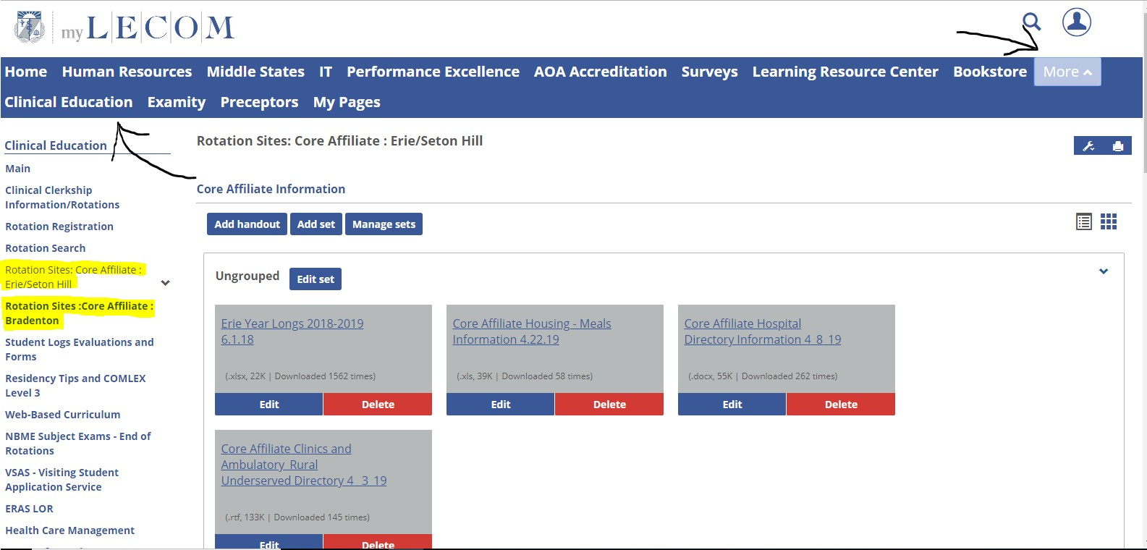

* 1. **Appendix E: EPAs (Entrustable Professional Activities)**

Entrustable Professional Activities (EPAs) offer a practical approach to assessing competence in real-world settings and impact both learners and patients.

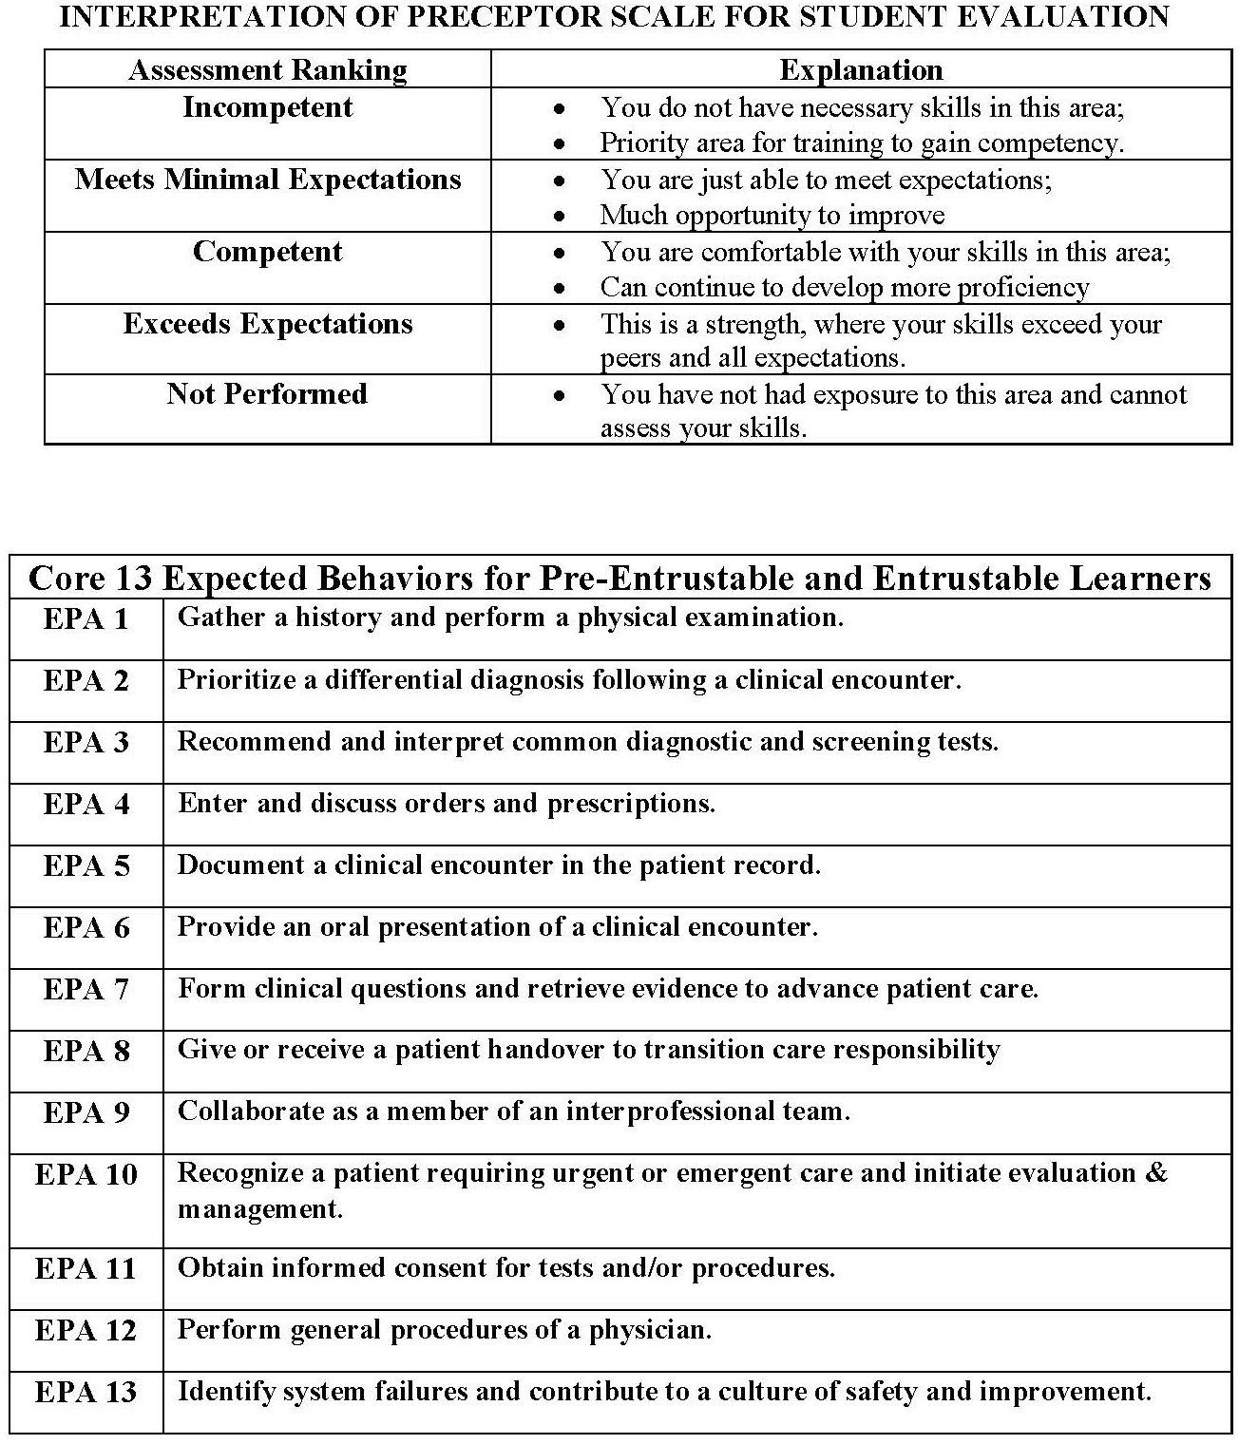

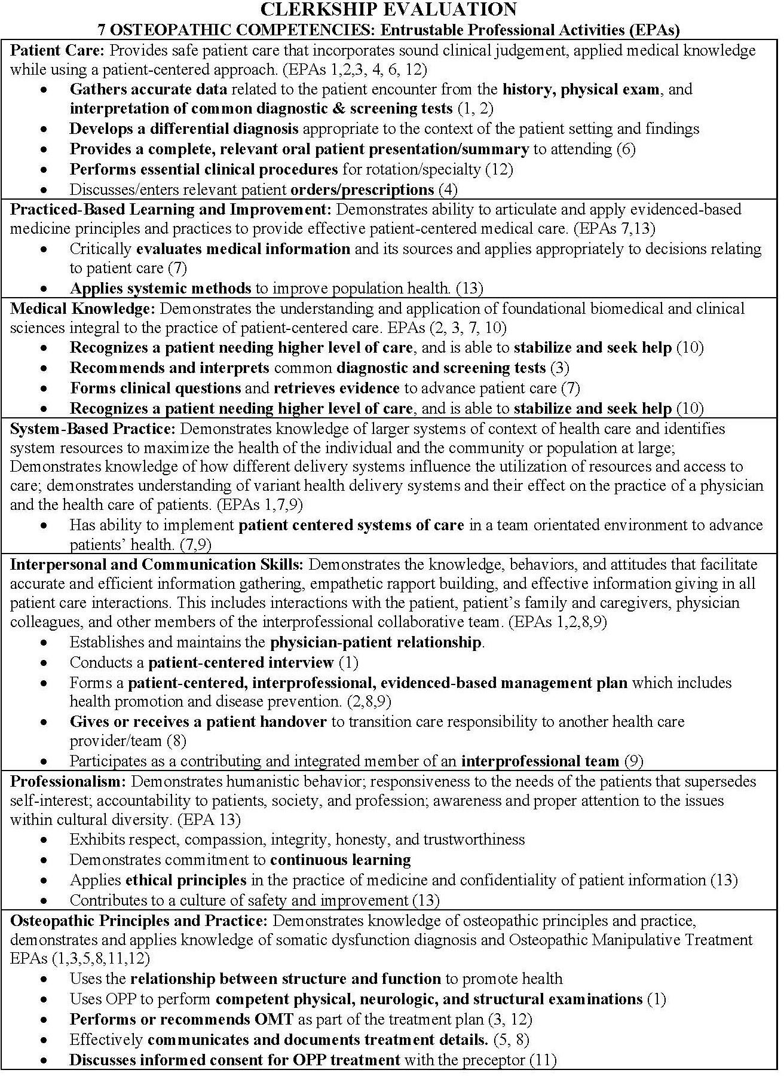

## Appendix F: Rotation Descriptions-Elective/Selective

(LDP, PBL, DSP)

**OMS3 ROTATIONS**

(48 weeks total required)

* The 3rd year of clinical training involves thirteen (13) four (4) week blocks
* **There are eight [8] blocks for core clerkships that occur at the year-long training site**:*

|  |  |  |  |  |  |  |
| --- | --- | --- | --- | --- | --- | --- |
| ***ROTATION*** | ***BLOCKS*** | ***WEEKS*** |  | ***ROTATION*** | ***BLOCKS*** | ***WEEKS*** |
| **Internal Medicine** | 3 | 12 |  | **OB/Gynecology** | 1 | 4 |
| **Surgery** | 2 | 8 |  | **Pediatrics** | 1 | 4 |
| **Psychiatry** | 1 | 4 |  |  |  |  |

**Other 3rd Year Rotations**:

|  |  |  |  |  |  |  |
| --- | --- | --- | --- | --- | --- | --- |
| ***ROTATION*** | ***BLOCKS*** | ***WEEKS*** |  | ***ROTATION*** | ***BLOCKS*** | ***WEEKS*** |
| **Clinical Education Enrichment (CEE)** (Time slot 1) | 1 | 4 |  | **Elective** | 1 | 4 |
| **Geriatrics/Osteopathic Principles & Practices** | 1 | 4 |  | **Vacation** | 1 | 4 |
| **Family Medicine#** (*May be provided at core site*) | 1 | 4 |  |  |  |  |

**OMS4 ROTATIONS**

(48 weeks total required)

* The 4th year of clinical training involves thirteen (13) four (4) week blocks
* **There are four [4] blocks for core clerkships that occur at the year-long training site**:*
  + Senior Capstone under direction of Core Site / Regional Dean

|  |  |  |  |  |  |  |
| --- | --- | --- | --- | --- | --- | --- |
| ***ROTATION*** | ***BLOCKS*** | ***WEEKS*** |  | ***ROTATION*** | ***BLOCKS*** | ***WEEKS*** |
| **Emergency Medicine** | 1 | 4 |  | **Senior Capstone** | 1 | 4 |
| **Ambulatory Medicine** | 2 | 8 |  |  |  |  |

**Other 4th Year Rotations:**

|  |  |  |  |  |  |  |
| --- | --- | --- | --- | --- | --- | --- |
| ***ROTATION*** | ***BLOCKS*** | ***WEEKS*** |  | ***ROTATION*** | ***BLOCKS*** | ***WEEKS*** |
| **Clinical Competency Development (CCD) Rotation** (Time slot 1) | 1 | 4 |  | **Electives** | 3 | 12 |
| **Primary Care Selective** [General IM, FM, OB/Gyn, or Peds] | 1 | 4 |  | **Vacation** | 1 | 4 |
| **Medical Selective** [General or Sub-specialty IM] | 1 | 4 |  |  |  |  |
| **Surgical Selective** [General or Sub-specialty Surgery] | 1 | 4 |  |  |  |  |
| **Rural/Underserved Ambulatory Selective##** | 1 | 4 |  |  |  |  |

*Must be with a Core affiliated hospital, if available

#Must be with a Family Medicine Board Certified Physicians

## Rural/Underserved can be completed in any specialty, as long as it is designated as such.

**SELECTIVE ROTATIONS** (Comprehensive list in Appendix K)

|  |  |  |
| --- | --- | --- |
| **PRIMARY CARE SELECTIVE** | **SURGICAL SELECTIVE** | **MEDICAL SELECTIVE** |
| Addiction Medicine | Anesthesiology | Addiction Medicine |
| Family Medicine | Dermatology | Allergy & Immunology |
| Geriatrics | Emergency Medicine | Cardiology |
| General Internal Medicine | ENT | Dermatology |
| Neonatal Intensive Care Unit | Forensic Pathology | Emergency Medicine |
| Obstetrics and Gynecology | General Surgery | Endocrinology |
| Osteopathic Manipulative Medicine | Ophthalmology | Gastroenterology |
| Pediatrics | Orthopedic Surgery | General Internal Medicine |
| Psychiatry | Otolaryngology | Hematology |
| Sports Medicine | Pain Management | Infectious Disease |
|  | Pediatric Surgery | ICU/CCU |
|  | Plastic Surgery | Nephrology |
|  | Radiology | Neurology |
|  | SICU | Oncology |
|  | Trauma/Burn Surgery | Pediatric sub-specialties (non-surgical) |
|  | Urology | Pulmonology |
|  |  | Pathology |
|  |  | Physical Medicine & Rehabilitation |
|  |  | Radiology |
|  |  | Rheumatology |

## Appendix G: General Patient Encounter Objectives

The following general objectives are expectations of competencies for each and all clinical rotations. They are designed to help the student develop the basic skills of medical problem solving, case management, procedural expertise, and professional demeanor. Some focus on data acquisition (medical history, physical examination, laboratory data, or literature review), while others deal purely with psychomotor skills or attitudes and feelings. The student is encouraged to review these objectives carefully as their progress and evaluation on each rotation will be mostly measured based on the criteria within these objectives.

As a result of each clinical rotation, the student should become better able to obtain adequate, logical, and sequential medical history. The student will include in the **history of present illness** (HPI) begins with an introduction of the patient, pertinent positive and negative features, which clearly demonstrate their thorough understanding of a patient’s problem(s). All drugs, treatments, and important previous milestones concerning that illness will be clearly noted. Students should refer to the History and Physical Courses for complete Subjective/Objective/Assessment/Plan (SOAP) Notes.

**Past Medical History:** Complete history of all medical conditions and illnesses, including timeframes, and possible hospitalizations.

**Past Surgical History:** All previous surgeries, including approximate dates and sequelae.All previous injuries and any sequelae.

**Medications:** Complete present medication use, including doses and lengths of time on the drug, prior drug experience, when applicable, supplements, and over-the-counter medications.

**Immunizations:** Immunizations, being up-to-date or not.

**Allergies:** All untoward drug reactions (allergic or toxic). This should include anesthetic agents and specific reactions. If none, it should be clearly noted.All other allergies, environmental and food.

**Social History:** Quantitative estimate of alcohol, tobacco, or illicit drug use.

**Family history** will contain all positive and negative age associated diseases with a familial tendency, or which may have a bearing on the HPI. It will also include a list of ages and health status of all first-degree relatives.

**Review of systems** will be complete and detailed, containing notation for each body system pertaining to the HPI. During the review of systems, system histories are mandatory for symptoms uncovered.

Perform and record an adequate **physical examination**, which includes:

* + Accurate and complete vital signs.
  + A thoughtful description of the patient's general appearance and behavior.
  + A thorough and complete description of physical findings pertinent to the HPI recording.
  + Careful attention to findings suggested by the past medical history or review of systems.
  + Identifying areas of somatic dysfunction when performing an osteopathic structural examination

The remainder of the physical examination must be sufficiently detailed to identify incidental abnormal findings not related to the present illness or positive historical clues.

The student documents a complete and legible H&P in the patient's medical record, written or EMR. It should include a brief summary statement, which demonstrates that the student has synthesized the historical and physical exam data. The student should be able to complete a history and physical examination in one hour. Orally present the patient's data and synthesis in 10-15 minutes in a logical sequential fashion, demonstrating the student’s understanding of the patient's basic disease process and its manifestations in his/her patient.

As students apply basic medical knowledge in synthesizing a differential diagnosis and plan of management to solve the patient's problems, they must be able to:

* + Synthesize from the subjective and objective information impression / diagnosis / assessment.
  + Generate a clear problem list.
  + Develop a plan of action.
  + Identify indicated laboratory tests.
  + Suggest a therapeutic plan of treatment consistent with the practices of osteopathic medicine, including the application of Osteopathic Manipulative Treatment when appropriate.
  + Review the pertinent literature to expand the student’s knowledge of the problem.
  + Define patient education objectives and assess the patient's understanding of their problems.

Students must also perform as an effective member of the site’s healthcare team and as their patients' primary physician by:

* + Gathering patient information and data and offering an interpretation of the data with regard to the patient's problems.
  + Reporting this data on rounds and in the progress notes. Progress notes should reflect a dispassionate report.
  + Acquiring sufficient knowledge and skill concerning the patient's problem to be considered "the local expert" by the health care team.

Demonstrate and develop the following affective attitudes, feelings, and behavioral characteristics:

* + Work with patients in a respectful, compassionate, caring, and empathetic manner.
  + Develop a professional attitude and demeanor in working with patients, peers, faculty, house staff, health care professionals, and other persons in the health care setting.
  + Identify and emulate appropriate role models among attendings and house staff including those who demonstrate the process of developing rapport and positive communications with patients, faculty, house staff, and other health care professionals.
  + Demonstrate the following professional behaviors: o Reliability and dependability
    - Self-awareness
    - Emotional intelligence and stability
    - Integrity and honesty
    - Initiative and enthusiasm
    - Punctuality
    - Self-education

## Appendix H: Student Request Form for Excused Absence

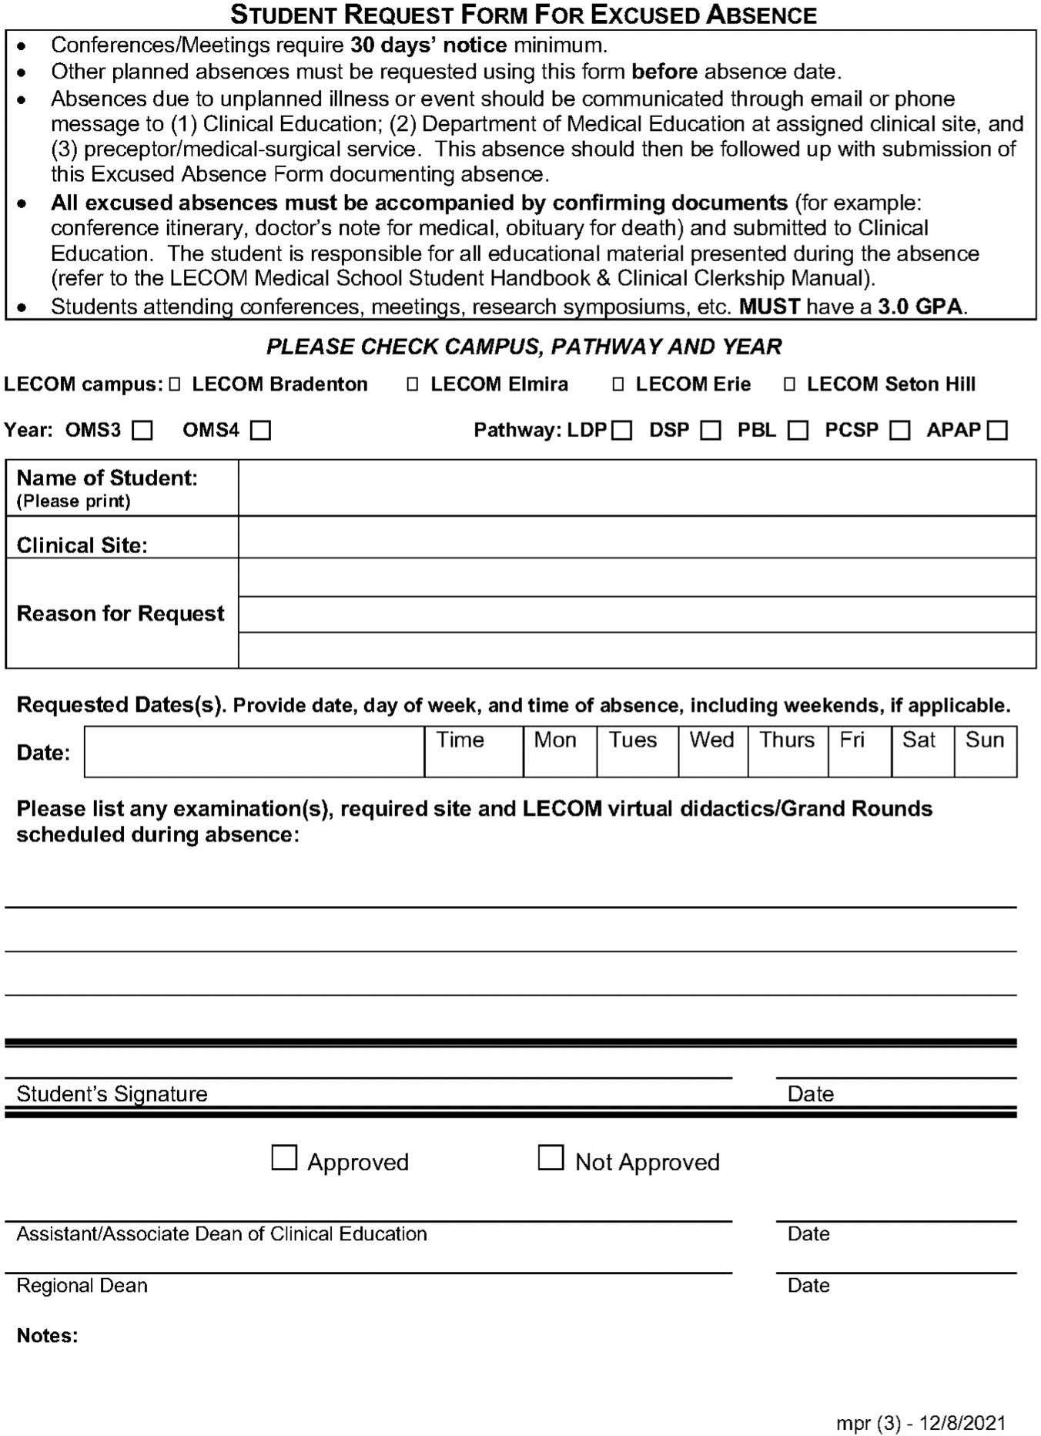

* 1. **Appendix I: Standards of Excellence**
     1. Treat all patients and visitors as individuals with unique problems and needs. Be responsible and display a positive, helpful attitude no matter how demanding or inconvenient such requests may seem.
     2. Acknowledge all patient complaints and resolve them immediately whenever possible. Report those that cannot be resolved to charge person in the area where the patient is receiving treatment.
     3. Address each patient by name. Introduce yourself by name and job title when addressing a patient for the first time.
     4. Acknowledge patients and visitors whenever entering patients' rooms.
     5. Explain any delays in treatment or service immediately to the patient.
     6. Respect the patient's right to dignity and privacy.
     7. Discuss patients and their medical records only in confidential settings and share such information only with staff members who have a need to know.
     8. Keep patients informed of their medical condition and the course of treatment being prescribed.
     9. Dress in a neat, clean, professional manner in accordance with applicable dress code policies and display your name tag prominently.
     10. Perform all duties in a courteous, prompt, and professional manner while observing hospital rules for quiet and efficient service.
     11. Interact with hospital staff in a considerate and helpful manner.
     12. Help keep the clinical training site’s environment clean and safe.
     13. Obey the clinical training site’s Rules, Regulations, Bylaws, Policies and Procedures.
     14. Students may not divulge any confidential or non-public information concerning employees, operations or strategic plans of the hospital.

(NOTE: Initial document-Richard Ferretti, JD on July 2006)

## Appendix J: COVID-19 Quarantine and Didactics

#### Please follow the following if you contract COVID-19 or get quarantined pending results of testing in order to ensure credit for your rotation:

**Please send an excused absence form to Clinical Education for days missed at the end of your quarantine. Use this** [**file**](https://docs.google.com/document/d/1FBk8xwzP9rNmubprO_4BmENS6U11CqIi/edit?rtpof=true)**:**

**You should log 6-8 hours per day of didactics: Use this file** [**here**](https://docs.google.com/file/d/1oX4zrJZxnCp1cgrcZBw0zC-o8wt-Jm6x/edit?usp=docslist_api&filetype=msexcel)

**If you are on a core rotation:**

* + Follow your core curriculum for that rotation
  + Complete the daily readings
  + Listen to the recommended podcasts
  + Complete daily True Learn questions
  + Complete at least three human dx cases
  + Participate in CP Solvers VMR each day (link on the google calendar)

#### If you are on an elective rotation:

**Please log your daily work and submit to the clinical education department at the end of your quarantine.**

* + Pick a virtual rotation in the electives tab on the portal and inform the clinical education department
  + Follow that curriculum daily and log your work
  + Complete the daily readings
  + Listen to the recommended podcasts
  + Complete daily True Learn questions
  + Complete at least three human dx cases
  + Participate in CP Solvers VMR each day (link on the google calendar)

#### PLEASE EMAIL YOUR FILLED OUT FORM AT THE END OF YOUR QUARANTINE IN ORDER TO GET CREDIT FOR YOUR ROTATION

**If you are leaving your clinical rotation to go home to loved ones and family, we would like to suggest that you consider:**

* + 1. Getting a COVID test before going home, and yes, one after.
    2. Maintain good COVID Posture around family and friends—I know that this can be tough to do—but you really do not want to give/receive the gift of illness!
    3. Be strategic in your social calendar and appointments. (More contact is more exposure)
    4. Be aware of the risks inherent with each mode of travel.
    5. Remember that it is just not COVID that is going around currently—but also influenza and RSV!
    6. It is ALWAYS better to be ultra-conservative and careful when it comes to family—especially our seniors and those who may be frail/have health issues.
    7. When in doubt—test to find out!
    8. Always keep your attending, rotation site, and regional dean aware of any issues.

#### NOTE: These instructions on this link

[**https://docs.google.com/document/d/13BQaQmVVquy7u6nxX-dU517smOpL**](https://docs.google.com/document/d/13BQaQmVVquy7u6nxX-dU517smOpLNTsT1iS4_n-2e9U/edit?usp=sharing)[**NTsT1iS4_n-2e9U/edit?usp=sharing**](https://docs.google.com/document/d/13BQaQmVVquy7u6nxX-dU517smOpLNTsT1iS4_n-2e9U/edit?usp=sharing)**.**

* 1. **Appendix K: Elective & Selective Matrix**

##### NOTE: If specialty not checked in the following report, MUST be an elective.

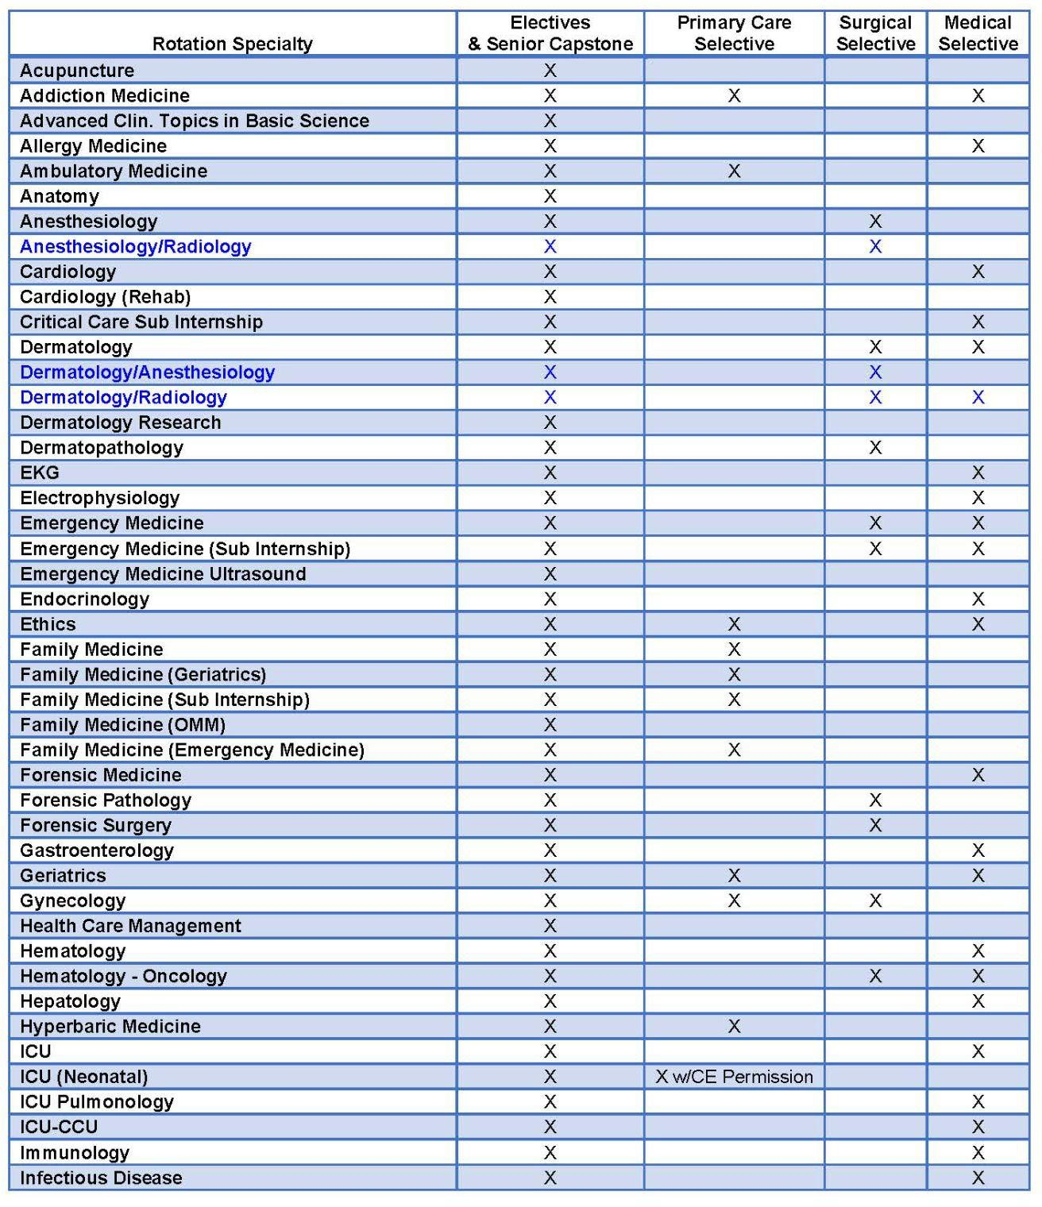

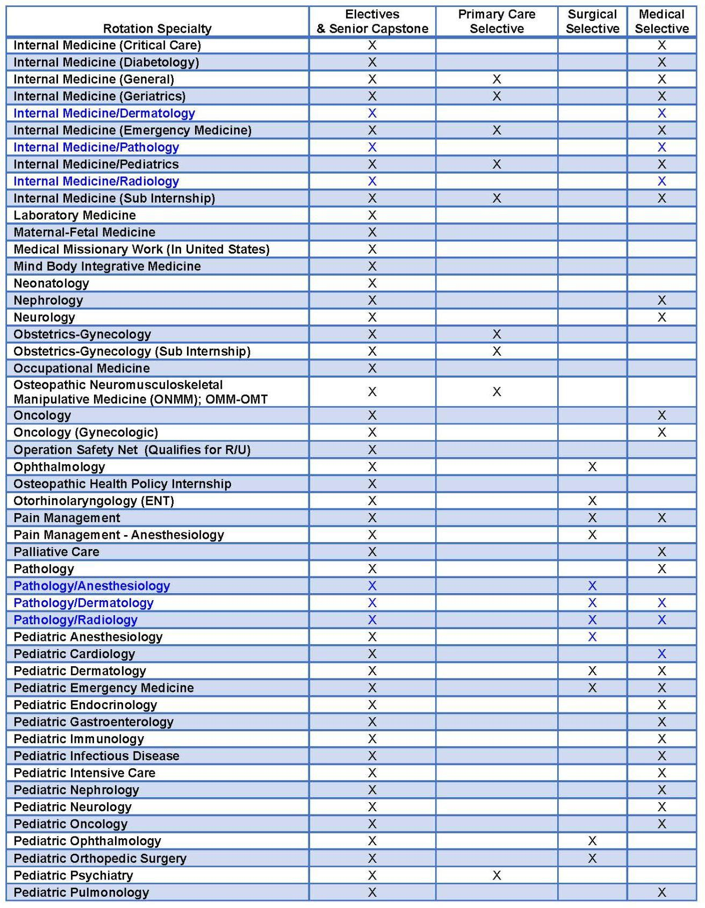

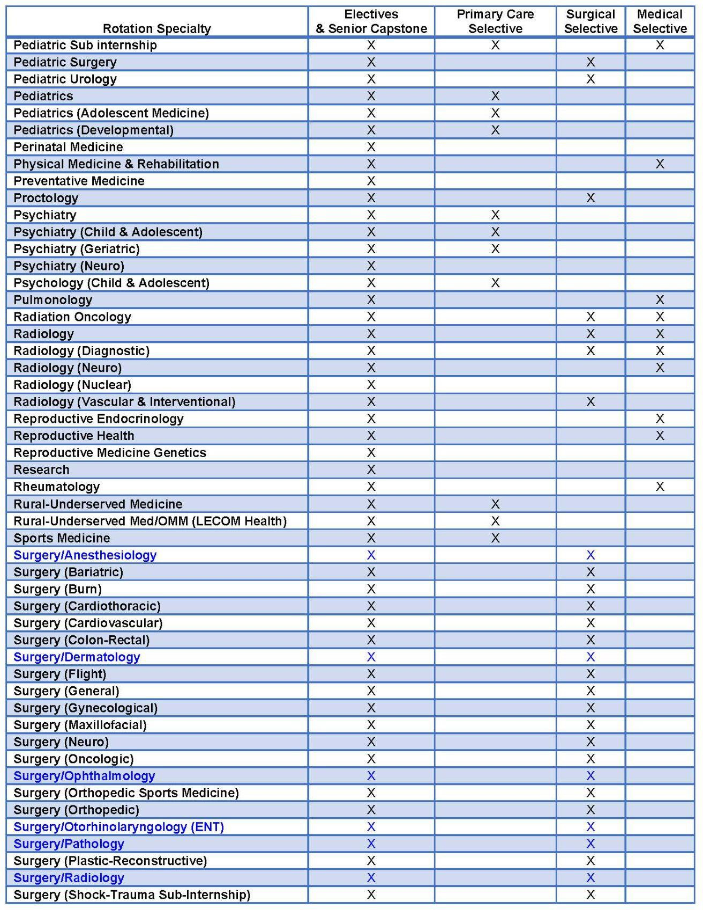

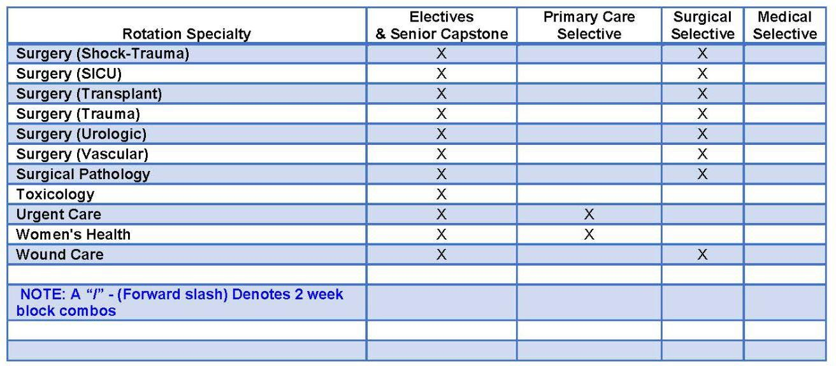

* 1. **Appendix L: Clinical Rotation Performance Evaluation Form**

**NOTE**: All clinical rotation performance evaluations are expected to be completed within E*Value. Under exceptional circumstances and approval by Clinical Education and the Regional Dean, a paper form may be used.

